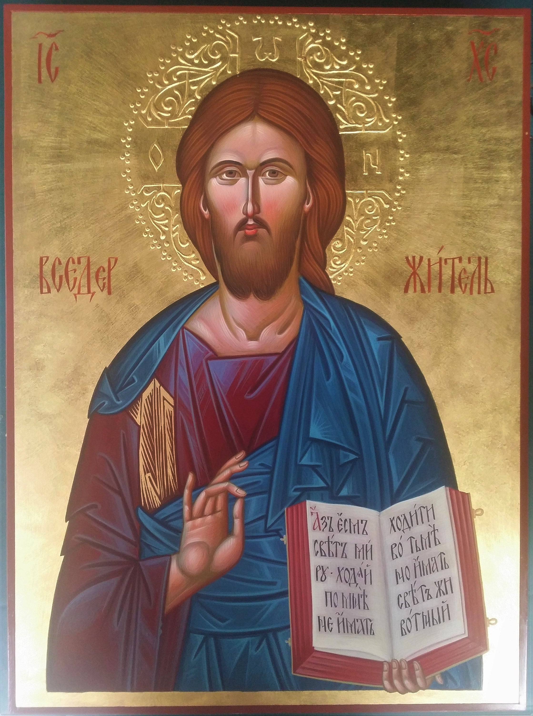
St. George Orthodox Church
2 Nottingham Terrace - Buffalo, NY 14216
(716) 875-4222

www.stgeorgebuffalo.com

NO. 533 NOVEMBER 19, 2023 _____________________ NOVEMBER 19, 2023 NO. 533
THE WEEKLY MESSENGER

Published weekly in the interest of the parishioners and friends
of Saint George Orthodox Church, Buffalo, NY
a parish of the Diocese of New York and New Jersey
and The Orthodox Church in America

ST. GEORGE ORTHODOX CHURCH

2 Nottingham Terrace Buffalo, NY 14216
V. Rev. Jason Vansuch, Parish Priest

2 Nottingham Terrace 716-875-4222 Buffalo, NY 14216

Cell Phone: 609-851-3811 Email: jvansuch@hotmail.com

Rev. Peter Irfan, Attached

Mat. Katia Vansuch, Choir Director

Dr. Boris Kuvshinoff, Parish Council President
Home: 716-812-6132 Email: boris.kuvshinoff@gmail.com
24th SUNDAY AFTER PENTECOST — Tone 7. Prophet Obadiah (Abdia—9th c. B.C.). Martyr Barlaam of Cæsarea in Cappadocia (ca. 304). Ven. Varlaam, Abbot of the Kiev Caves (Near Caves—1065). Finding of the relics of Monastic Martyr Adrian of Poshekhónsk (Yaroslavl’—1625). Martyr Azes of Isauria and 150 soldiers with him (3rd c.). Martyr Heliodorus in Pamphylia (ca. 273). Ven. Hilarion the Wonderworker, Monk of Thessalonica (Georgian—875). Repose of St. Philaret (Drozdov), Metropolitan of Moscow (1867). Saints Barlaam the monk and Prince Ioasaph of India
_____________________________________________________________________
EPISTLE: Liturgy of St. John Chrysostom GOSPEL:
Ephesians 2:14-22 Luke 12:16-21
______________________________________________________________________________
__________________________________________________________________________________________________________________________________________________________________________________________________________________________________________________________________________________________________________________________________________________________________________________________________________________________________________________________________________________________________________________________________________________________________________________________________________________________________________________

GLORY TO JESUS CHRIST! GLORY FOREVER!

**FLOWERS FOR THIS WEEK**
In front of the Icon of Our Lord, In front of the Icon of The Theotokos,
and on the Center Icon Table are donated by St. George Orthodox Church!
+++++++++++++++++++++++++++++++++++++++++++
Altar Vigil Candles are offered by Anthony DelNuovo in Loving Memory
of Thy Departed Servants of his family. May their memory be eternal.
+++++++++++++++++++++++++++++++++++++++++++
TODAY’S WEEKLY MESSENGER IS SPONSORED BY:
St. George Orthodox Church

WELCOME TO ST. GEORGE ORTHODOX CHURCH
We welcome all of you to the Divine Liturgy this morning, especially those who are visiting with us here at St. George Orthodox Church. Everyone is invited to the Parish Fellowship Hall following the Divine Liturgy for Christian Fellowship. It is our prayer that your experience this morning was spiritually uplifting and you will return very soon to pray with our parish family. In the Orthodox Church, we do not practice open Communion. However we do invite everyone to come and participate in the Divine Liturgy. Hence only those Orthodox Christians who have properly prepared themselves through prayer and fasting may receive Holy Communion. May the Lord bless you with many years of good health and happiness.
HYMNS FOR THE DIVINE LITURGY

Tropar for The Resurrection, Tone 7

By Thy Cross Thou didst destroy death. To the thief Thou didst open Paradise.For the Myrrhbearers Thou didst change weeping into joy, and Thou didst command Thy disciples, O Christ God, to proclaim that Thou art risen,// granting the world great mercy.

Tropar for The Great-Martyr Barlaam, Tone 4
Armed with youthful fervor, thou didst endure martyrdom in old age and didst glorify Christ. Thou didst offer Him thy right hand as a whole burnt offering and thy holy soul as a blameless sacrifice.// Intercede that all that be granted forgiveness, Great-martyr Barlaam.

Glory to the Father, and to the Son, and to the Holy Spirit.

Kontakion for The Resurrection, Tone 7

The dominion of death can no longer hold men captive, for Christ descended, shattering and destroying its powers. Hell is bound, while the Prophets rejoice and cry: “The Savior has come to those in faith;// enter, you faithful, into the Resurrection!”

Now and ever and unto ages of ages. Amen.

Steadfast Protectress Tone 6
Steadfast Protectress of Christians, constant advocate before the Creator. Despise not the entreating cry of us sinners, but in Your Goodness come speedily to help us who call on You in faith! Hasten to hear our petition and to intercede for us, O Theotokos!! For You always protect those who honor You!

THE PROKEMEINON – TONE 7
The Lord shall give strength to His people. / The Lord shall bless His people with peace. V. Offer to the Lord, O you sons of God! Offer young rams to the Lord!

ALLELUIA VERSES

It is good to give thanks to the Lord, to sing praises to Thy Name, O Most High.
To declare Thy mercy in the morning, and Thy truth by night.

THE HYMN TO THE THEOTOKOS

It is truly meet to bless You, O Theotokos, ever blessed and most pure and the Mother of our God. More honorable than the Cherubim and more glorious beyond compare than the Seraphim. Without defilement, You gave birth to God the Word, true Theotokos, we magnify You!

COMMUNION HYMN
Praise the Lord from the heavens, praise Him in the highest! Alleluia! Alleluia! Alleluia!
EPISTLE LESSON FOR TODAY

Brethren:

For He Himself is our peace, who has made both one, and has broken down the middle wall of separation, having abolished in His flesh the enmity, that is, the law of commandments contained in ordinances, so as to create in Himself one new man from the two, thus making peace, and that He might reconcile them both to God in one body through the cross, thereby putting to death the enmity.

And He came and preached peace to you who were afar off and to those who were near.

For through Him we both have access by one Spirit to the Father.

Now, therefore, you are no longer strangers and foreigners, but fellow citizens with the saints and members of the household of God, having been built on the foundation of the apostles and prophets, Jesus Christ Himself being the chief cornerstone, in whom the whole building, being fitted together, grows into a holy temple in the Lord,

in whom you also are being built together for a dwelling place of God in the Spirit.

GOSPEL LESSON FOR TODAY

LET US ATTEND:

Then He spoke a parable to them, saying: “The ground of a certain rich man yielded plentifully. And he thought within himself, saying, ‘What shall I do, since I have no room to store my crops?’

So he said, ‘I will do this: I will pull down my barns and build greater, and there I will store all my crops and my goods.

‘And I will say to my soul, “Soul, you have many goods laid up for many years; take your ease; eat, drink, and be merry.”’

But God said to him, ‘Fool! This night your soul will be required of you; then whose will those things be which you have provided?’

So is he who lays up treasure for himself, and is not rich toward God.”

=========================================================
= = = Scriptural Readings for the Week = = =

PLEASE REFER TO THE OCA WEBSITE…www.oca.org
=========================================================

THE SCHEDULE OF WEEKLY SERVICES and ACTIVITIES

SUNDAY NOVEMBER 19, 2023
Matins – 9:00 AM Divine Liturgy – 10:00 AM
Church School Class in Parish Fellowship Hall following The Divine Liturgy!

Coffee Hour Reception in honor of Paul Olczak and Anna and Alex (11th Birthday) and Fellowship in Parish Fellowship Hall following The Divine Liturgy!
St. George Prayer Group Meeting

MONDAY NOVEMBER 20, 2023
THE EVE OF THE GREAT FEAST OF THE ENTRANCE OF
THE THEOTOKOS INTO THE TEMPLE

Great Vespers with Litiya - 4:00 PM (PLEASE NOTE TIME CHANGE)

TUESDAY NOVEMBER 21, 2023
THE GREAT FEAST OF THE ENTRANCE OF
THE THEOTOKOS INTO THE TEMPLE

Festal Divine Liturgy – 9:00 AM

THURSDAY NOVEMBER 23, 2023
THANKSGIVING DAY

Moleben Prayer Service of Thanksgiving - 9:00 AM

As we gather together with our families and friends on this Day, let us take time out and give thanks to God for those blessings, seen and unseen, He has graciously bestowed upon us during this past year. Also, let us remember our loved ones who now lie asleep in the Lord in the Heavenly Kingdom and may their memories be eternal. May all of you, your families, and our beloved parish family have a Blessed, Happy, and Healthy Thanksgiving.

SATURDAY NOVEMBER 25, 2023
Great Vespers – 4:00 PM

SUNDAY NOVEMBER 26, 2023
Matins – 9:00 AM Divine Liturgy – 10:00 AM
Church School Class in Parish Fellowship Hall following The Divine Liturgy!

Coffee Hour Fellowship in Parish Fellowship Hall following The Divine Liturgy!


If anyone has any questions about fasting or restrictions when hosting coffee hour, please see Fr. Jason and he will help you and guide you!

When hosting coffee hour, please check the refrigerators in the Parish Fellowship Hall the week before we are histing to see what supplies we will/may need.

We will also be using real coffee cups for coffee hour. If anyone needs assistance with cleaning them or using the dishwasher following Coffee Hour, please see or contact Mat. Katia.

If there is no host for coffee hour,
then we will not have coffee hour on that particular Sunday.

If anyone would like to host coffee hour or has any questions regarding one’s preparations for Coffee Hour, please see or contact Mat. Fran (610.698.1666/frances.vansuch@yahoo.com)

**The 2024 Coffee Hour Schedule will be available at the end of October !**


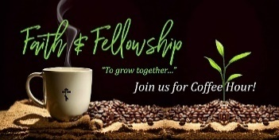

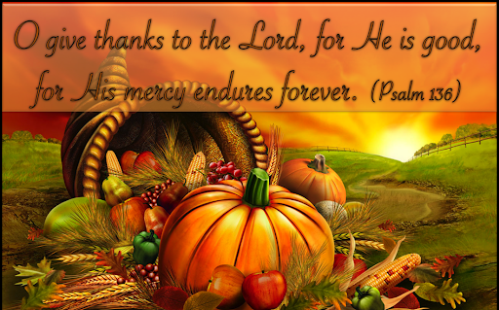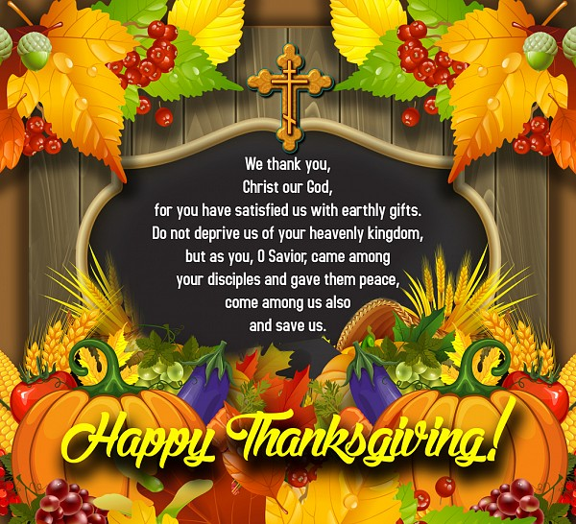

FIND YOUR SPIRITUAL HOME
In The Orthodox Christian Church
SATURDAY Great Vespers 4:00 PM
SUNDAY Divine Liturgy 10:00 AM (Sept-May)
9:30 AM (May-September)
~ All are Welcome ~
Do we have questions about our life, its meaning, purpose, destiny?
Are we desiring to know Jesus Christ, the Son of the living God?
Are we seeking forgiveness, healing, and wholeness?
Do we wonder where to go to find answers?
We can find the answers to these questions and so many other questions
in The Holy Orthodox Church through Her Sacred Tradition,
Holy Scriptures, Her Teachings and Dogmas.

The Orthodox Church is the original Christian Church, the Church founded by the Lord Jesus Christ and described in the pages of the New Testament. Her history can be traced in unbroken continuity all the way back to Christ and His Twelve Apostles, empowered and sent forth on the day of Holy Pentecost. Incredible as it seems, for over twenty centuries she has continued in her undiminished and unaltered faith and practice. Today her apostolic doctrine, worship, and structure remain intact. The Orthodox Church maintains that the Church is the living Body of Jesus Christ. Many of us are surprised to learn that for the first 1000 years of Christian history there was just one Church.

Where is "The Church" to be found and experienced today? Come Taste and See How Good The Lord is every Sunday by joining us for The Divine Liturgy at 10:00 AM.
What is Orthodox Christianity all about? How does it differ from other Christian confessions? This section will attempt to answer these questions and many more.
For a visual introduction to the Orthodox Church, please view the video link below:
http://www.youtube.com/v/Gj4pUphDitA&color1=0xb1b1b1&color2=0xcfcfcf&feature=player_embedded&fs=1”

For a brief introduction and in depth study to The Orthodox Faith and to find answers to: ‘What we Believe?” , “Who we Are?”, and “How we Live?’, please view the PDF link below:

http://orthodoxdelmarva.org/files/studies/InquirersClassV1final.pdf

or you may visit the OCA website by clicking the link below:
http://oca.org/orthodoxy/the-orthodox-faith

or you can begin a Journey Through Orthodoxy by clicking the link below:
http://journeytoorthodoxy.com

To learn more ways that we can teach our children about the Orthodox Faith, The OCA has provided a wonderful website for us to use that provides great resources such as (handouts, texts, articles, stories, and much more)! To see this great website, please view the PDF link below:
http://dce.oca.org/page/resources/

If you have any questions or would like to know more about The Orthodox Faith or needs and help or assistance, please contact our parish priest: V Rev. Jason Vansuch (jvansuch@hotmail.com) or 716.875.4222 and he will be able guide you.

To visit our parish website, please click on the QR Code below:



Come and See how we are all called to
be Stewards of The Church!

- Stewardship is our active commitment to use all our time, talent and treasure for the benefit of humankind in grateful acknowledgment of Christ's redeeming love.
- Stewardship is caring for the needs of others.
- Stewardship is offering one's self to God as He offered Himself to us.
- Stewardship is what a person does after saying "I Believe . . . ", as proof of that belief.
- Stewardship is learning how to be a responsible and concerned caretaker of Christ's Church; it is learning how to enjoy Church life and be happy in Church work, for in Her dwells the fullness of the Spirit of God.

If you would like to make a donation to our parish, please feel free to use the QR Code or link to our parish website donation page below. Thank you for your continued support and generosity for our parish in bringing The Love and Faith of Our Lord Jesus Christ to all! May God continue to bless and guide you and keep all of you in His loving care today and always!


https://www.paypal.com/donate/?hosted_button_id=E5X6YTVC9DF3W

MONTHLY HEALING PRAYER SERVICE
The Supplicatory Canon
Prayer Service to St. Nektarios

MONDAY NOVEMBER 27, 2023 –6:00 PM

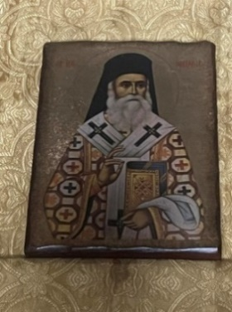

LET ALL THAT YOU DO BE DONE IN LOVE. 1 Cor.16:14

YOU SHALL LOVE THE LORD YOUR GOD WITH ALL YOUR HEART, AND WITH ALL YOUR SOUL, AND WITH ALL YOUR MIND. Matt. 22:37

YOU SHALL LOVE YOUR NEIGHBOR AS YOURSELF. Matt. 22:39

LOVE YOUR ENEMIES AND PRAY FOR THOSE WHO PERSECUTE YOU. Matt. 5:44

LOVE IS PATIENT, LOVE IS KIND, LOVE DOES NOT ENVY, LOVE DOES NOT BOAST, LOVE IS NOT PROUD, LOVE IS NOT SELFISH, LOVE IS NOT PROVOKED. 1Cor. 13:4

LOVE BEARS ALL THINGS, LOVE ALWAYS HAS FAITH, LOVE ALWAYS HAS HOPE, LOVE ENDURES ALL THINGS. LOVE NEVER FAILS! 1Cor. 13:7,8

ST. GEORGE SENIOR/RETIREE DAY
THURSDAY NOVEMBER 16
10:00 am to 12:00 PM
We invite all Seniors and Retirees to come and join us as we spend a morning together in prayer and Christian fellowship!
- A morning filled with prayer, fellowship, education and fun for all of our retired parishioners to come together and spend time together
- Coffee, tea, juice and snacks will be provided
- Held 1-2x a month

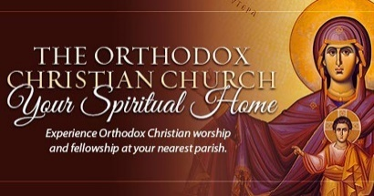

ST. GEORGE ORTHODOX CHURCH ANNUAL CHRISTMAS CARD

NOVEMBER thru DECEMBER

ST. GEORGE ORTHODOX CHURCH CHRISTMAS

COOKIE TRAY SALE/POINSETTIA SALE/BASKET RAFFLE

NOVEMBER thru DECEMBER

ASSEMBLING OF COOKIE TRAYS - SATURDAY DECEMBER 16

COOKIE TRAY SALE PICK-UP AND BASKET RAFFLE DRAWING - SUNDAY DECEMBER 17

** Parish Family Night – Friday December 2
**Annual Parish Meeting -- Sunday December 10
** Outing to Fatima Shrine – Friday December 15
** Parish Outing to “It was a wonderful life” – Sunday December 17
** Christmas Caroling – Sunday December 17

ST. GEORGE ORTHODOX CHURCH (Buffalo, NY)
PARISH OUTREACH MINISTRIES

To the Glory of God, every year our beloved parish family answers The Call of Our Lord of ministering to those in need by fulfilling The Gospel of Our Lord God and Savior Jesus Christ with participating in 5 on-going Parish Outreach Ministries within the local Buffalo Area on an on-going basis and especially during the Nativity Season.

Every year, we look forward to another wonderful blessed Nativity Season of bringing the joy, the love, and the peace of The Nativity of Our Lord to everyone especially through the following the outreach ministries:

Hearts for The Homeless – which is a mobile soup kitchen/thrift shop that feeds the poor and chronic homeless on the street. Characterized by a profound spiritual motivation. The program offers nourishing food, as well as clothing, pertinent information regarding area services, companionship and hope for the future.
- Each Month we collect a different canned good/non-perishable food item along with hygiene products and drop them off at the Hearts for The Homeless Distribution Center

Buffalo City Mission – exists to meet the spiritual and practical needs of the poor through the demonstration of the love and preaching of the Gospel of Jesus Christ in providing love, care, shelter, food, and other means necessary to those in need.
- Each Month we collect hygiene products, clothing for men, women, and children and drop them off at the Buffalo City Mission Distribution Center

HomeSpace – is a local community organization ministering to local teens and pre-teen moms which provides comprehensive care to 14-21 yr old moms (providing those essential items necessary for caring for their children: diapers, wipes, baby food, clothing (infants through 7/8 years old). Homespace Corporation supports at-risk young women to achieve independence two generations at a time.
- Each Month we collect hygiene products, clothing for young women and children along with those essential items necessary for caring for their children: diapers, wipes, baby food, clothing (infants through 7/8 years old) and drop them off at the HomeSpace Distribution Center

Mats for Mission/Resurrection Life Food Pantry – A Local Organization assisting with providing rest mats made out of plastic bags for the less fortunate as well as providing food and other means necessary to those in need.

- Each Month we collect plastic bags as well as canned goods and non-perishable food items and drop them off at the Resurrection Life Food Pantry Distribution Center.

- Beginning in January 2023, our church school children will be volunteering here on a regular basis assisting with collecting and sorting out Food Bags for those in need.

Baker Victory – A Local Organization dedicated to fostering the highest possible quality of life and personal achievement by partnering with children, adults, their families and the WNY community through a diverse array of social, health and human services.
- Twice a year we collect gifts and other essential items necessary for the children and drop them off at the Baker Victory Distribution Center.

**We also support Compass Care Pro-Life Agency and FeedMore of WNY on a regular basis!

++++++++++++++++++++++++++++++++++++++++++++++
MAY GOD CONTINUE TO BLESS YOU AND GUIDE YOU
FOR YOUR CONTINUED SUPPORT AND PRAYERS!
++++++++++++++++++++++++++++++++++++++++++++++

++++++++++++++++++++++++++++++++++++++++++++++++++++++++++++++

**PLEASE REFER TO THE WEEKLY EMAILS AND PARISH WEBSITE
FOR CHANGES TO THE CALENDAR!**

++++++++++++++++++++++++++++++++++++++++++++++++++++++++++++++
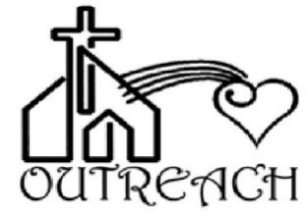
Remember our Loved Ones during Our Daily Prayers

‘Assuredly, I say to you, inasmuch as you did it to one of the
least of these My brethren, you did it to Me.’

{Matt. 25:40}

As we say our daily prayers, let us also take time out to remember our loved ones who are homebound, who are in hospitals and who are in nursing homes. Let us remember them that GOD will continue to watch over them and protect them. Also, during the Year, let us take to either send them a card, give them a call, or visit them to let them know how much we love them, how much we remember them, and how much we pray for them.

Please refer to the of our Parish Shut-Ins below.

If anyone has any questions or would like to add someone to our List of Parish Shut-Ins, please see or contact Fr. Jason. May God continue to bless you and guide you!

ST. GEORGE ORTHODOX CHURCH PARISH SHUT-INS (2023)

Reader Victor Shanchuk Mrs. Luba Japadjief

McAuley Residence Elderwood Nursing Home
1503 Military Rd. 104 Old Niagara Rd.
Buffalo, NY 14217 Lockport, NY 14221 (Room 47A)
716.881.3096

Mr. Albert Fadell Nicholas Wityk Mr. Steve Scordalakis
317.376.2562 Turtle Rock Road 122 Pennsylvania Ave
Livonia, NY Lockport, NY 14221
Andrew Wityk
Ellicott Center
200 Seventh Street
Buffalo, NY 14201

** NEW COFFEE HOUR SCHEDULE FOR 2023 IN THE PARISH FELLOWSHIP HALL! BE SURE TO SIGN UP TO HOST A COFFEE HOUR! PLEASE JOIN US EVERY SUNDAY IN THE PARISH FELLOWSHIP HALL FOLLOWING THE DIVINE LITURGY FOR SOME CHRISTIAN FELLOWSHIP WITH ONE ANOTHER!**

ST. GEORGE ORTHODOX CHURCH PRAYER LIST
Please remember in prayer Thy Servants of God…
FOR THE HEALTH OF THY SERVANTS:
HIERARCHS
Archbishop BENJAMIN Archbishop ALEJO
Archbishop NATHANIEL Archbishop DANIEL

CLERGY
Archpriest Herman, Matushka Cynthia and George, Elizabeth
Archpriest Vladimir and Matushka Jeanne
Archpriest Alexey and his family
Archpriest Timmothy/Mat. Michelle
Archpriest John and Presbytera Nancy
Archpriest Ken and Matushka Natalie
Archpriest Andreja, Popadija Anica and Family
Archpriest Timmothy Archpriest Leonid Archpriest David
Archpriest John (Onofrey) Archpriest James Archpriest Robert
Priest Peter and Mat. Mary
Dn. Sean and Mat. Heather
Dn. Mark and his family

MATUSHKI Mat. Deborah Popadija Sara Mat. Gayle Mat. Natasha
Mat. Barbara Mat. Katia Mat. Paraskeva Mat. Joanna Popadia Vicki Mat. Patricia Mat. Gloria Christine Coard Karen
Catherine Ivan/Marina/Inna Bonnie/Silviu Jennifer, Amanda
Edwina Irene Luba Jim, Darren, Marsha
Serena/Asma Lillian Reader Victor Nicholas, Andrew Marilyn Frank June Theodora Amanda, Chase Ronald, Candice
Sarah Albert Boris Oscar Billy Clyde
Xenia, Justin, Danielle, Anne, Patricia Larry Joseph Frank
Victor Catherine Susan Svetlana Juliana
Evelyn Robert Rebecca Paul Brian
Jeanne Angela, Jason, Michelle Linda Justin Frances
John, Helen Ashley Steven Barbara Daniel
Joseph, John, Margaret, Thomas, Victoria, Tyler Matthew William
Melody Natalie, Lorraine Lee, Maribeth Bridget
Kelly, Robert, Boris, Zaeb, Tirza, Sabas, Sada, Charles, Thlisinitsa,
Gemmal, Geesa, and Patric Lia/Isaiah
Olga and Eugene Jeremy Stewart Susan
Susan Justin Louis Yuri/Elena Alex John, Kevin, Sean
Anthony Aldona, Melinda, Pam Valerie Mary John Rebecca
Jaime/Sammy, Juliana Harry James
Lee, Benjamin, Harry Patrick Aspasia/Stavros
Charles Emma/Alexander Elias, John, Joseph, Nadim, Theresa
Vadym Iryna Yuriy Anastasia Rosemary Anthony Seraphim Anthony
Mary, Hal, Autumn, Ariana, and Amber, Judithann Anita, James, Jeffry, Dominic, Douglas, Rachel, Dennis, Edith, Robert, Joanna
Brian John, Roberta, Barbara John, Michael John
George Costa Jonathan, Kevin, Lary, Carly, Sherry, Mary Jo, Clara, Karl, Mary Al and Sophie and Family
Stephen, Larry, Olga, Olga, Sally, Deborah, David
Rdr Nicholas, Judithann, Michael, Mary, Cate, Michael, Gary, Damian, Olga, Alexandra, Barbara, Damian
Ron, Illiana, Jillian, Joel, Robert, Susan, Arnold, Kyriaki, Danny, Thomas, Amelia, Emily, Kevin/Juanita

Crissy and the child Luke Raphael born of her
Children of God – Jake

Diocese of NY&NJ Prayer List
Archpriest Samuel Mitred Archpriest Joseph Lickwar
Mitred Archpriest Daniel and Mat. Myra
Archpriest George Archpriest Paul Mitred Archpriest Ken (Starevsky)
Archpriest Jonathan Archpriest Paul

Those Serving in The Armed Forces
Kenneth, Nadine, Jason, Robert, Andrew, Justin, Shawn,
Austin, Chris, John, Daniel, Gjorgie, Thomas

Inquirers
William and Darlene Matthew Ayden Edward
Rudy and Karen Paul Judy Raymon/ Gina Raymond and Frankie

For All of our Parishioners and their families, the communicants of this holy house, those who pray here, our loved ones and their families and for those who are praying with us today and all of those whom we have in our hearts and minds

For All of our parishioners who are in hospitals, nursing home, and those who are homebound.

For All of the ill-afflicted of our parishes and families especially those affected with the Coronavirus and other ailments and for their continued full recovery and good health
For All of our doctors, nurses, physicians, and medical professionals

For our Nation that The Lord our God will continue to bless us and guide and teach us to love another, pray for one another and forgive one another.

For All of those who are travelling and for their safe journey and return to their homes

FOR THY DEPARTED SERVANTS OF GOD:

For all of those who tragically lost their lives to the Coronavirus and other ailments
All of the clergy and parishioners of This Holy House who have departed this life, who now lie asleep in the Lord

.
Metropolitan THEODOSIUS Metropolitan HERMAN
Ever-Memorable Archpriest Eugene Ever-Memorable Archpriest Bernard
Ever-Memorable Archpriest Rastko Ever-Memorable Archpriest George
Ever-Memorable Priest John Ever-Memorable Archpriest George
Ever-Memorable Dn. Mark Matushka Dorothy
Khouria Grace

Priest Leonid Gregory, Priest Peter, Archpriest Kirill, Dn. Michael, John Robert, Sister Thomas, Frank, Jenny, Charles, Florence, Michael Stevens, William, George, Marion

Ever-Memorable Pdn Gregory Ever-Memorable Sbdn Gregory

Martha, Akhtar, Barkat, Rehmat

Newly-Departed Servants of God
Anthony Dipiano Konstantinos Marie
James Kelly Vasili (William) – Father of Fr. Stephen Gousios
Matushka Delores Dragica (mother of Christine Hoeplinger) Mat. Priscilla

*If anyone would like to have their loved ones added to the prayer list
for remembrance during the Divine Liturgy and Divine Services, please see or contact Fr. Jason.

ST. GEORGE ORTHODOX CHURCH BOOKSTORE
As you are in the Parish Fellowship Hall for coffee hour, don't forget to check out our newly-formed Bookstore. We have some new items that just arrived. These items include: Icon ornaments, jewelry, Icons, prayer books, prayers ropes, and much more. If you need a Gift, come check out the Bookstore…you may find something you like!! We are now also offering Gift Certificates for our Bookstore. Please speak with Dave or Andrea for more details/information!! We thank David and Andrea Chmiel who are managing of our Bookstore for us. If you have any questions or if you would like to order something that you do not see, please see or contact David or Andrea Chmiel and they will be able to assist you. You may also email them at: bookstore@stgeorgebuffalo.com. May GOD continue to bless and guide all of you.

Also in the Parish Fellowship Hall, we have the Giving Tree! If anyone would like to sign up for Readers, Bulletin, Collection, Communion Cloth, Home Blessing, please see or contact Fr. Jason!

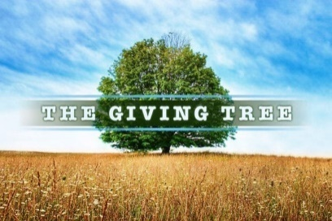

A SINCERE AND HEARTFELT THANKS AND APPRECIATION FOR THE FOLLOWING DONATIONS TO THE PARISH FROM OUR PARISH GIVING TREE

Please be sure to check out “The Giving Tree” in the Parish Fellowship Hall as well as on our parish website (www.stgeorgebuffalo.com) to see how we may be able to donate towards the needs of our parish through our continued support and stewardship for our beloved parish.

Some of the items on the leaves are as follows:

Candles
7-Day Vigil Candles
Flowers for Feast Days
Charcoal
Altar Wine
Cups for Zapifka
Paper Towels Toilet Paper Donation for Office Supplies (Paper, Copier)
Monthly Donation for Health Kits for Mats for Mission
Monthly Donation for Chowder Sale

If anyone has any questions, please see or contact Fr. Jason or Barbara. Thank you for your continued prayerful support and stewardship. May God continue to bless and guide all of you, your families and our entire Parish family and keep all of us in His Loving Care!
DAILY FAMILY PRAYER RULE WE CAN PRAY TOGETHER AT HOME WITH OUR FAMILIES

A Prayer Rule must be done in front of the icons and the Gospel in our Icon Corners with a lit candle.. It is important to remember that we must make time for God, for the “Kingdom of heaven suffers violence, and the violent take it by force”(Matt. 11:12).The best time to pray is in the morning or in the evening when we as a family can come together in prayer. Also, when using a Rule of Prayer, we must be flexible and do what we can and do it attentively and consistently. Our goal is to maintain the connection with God and cultivate a real relationship with Him.

With that in mind, please fine below The Rule of Prayer offered by our Diocese for us to use at home especially during this most difficult time when we are not able to be in church together as a parish family.

https://www.nynjoca.org/files/2020/praying-at-home/A-FAMILY-PRAYER-RULE.pdf

May God bless you and keep you always in His Loving Care!

An Invitation to Support the Stewards of the OCA!
The Orthodox Church in America (OCA) set the direction for expanding our apostolic work in North America at the 18th All-American Council. The foundation for this work is Jesus Christ, Whom we encounter in our spiritual lives, stewardship, evangelism and outreach, and relations with others as we engage the world. Being a steward of the OCA goes beyond the financial gifts which support the work of our church. Being a steward is about caring for and knowing the history of the mission of the Orthodox Church here in North America and finding your place in that history. Having received this great gift of our Orthodox Faith, we bear the responsibility to continue the legacy of Saint Herman and Saint Tikhon; Saint Innocent and Saint Alexis and all the other saints known and unknown who have worked to build up and expand Christ's Church here in North America. Please consider being a part of that mission today by giving to the Stewards of the OCA. For more information, please visit The OCA Website: https://oca.org/become-a-steward

+++++++++++++++++

An Invitation to Support the Ministry of the DDB!
In order to fund necessary ministries and fulfill the work of the Church in the Diocese of New York and New Jersey, Distinguished Diocesan Benefactors generously contribute financial support. To learn more about the DDB, please go to the following link: http://vimeo.com/71021182 and watch a 60 second video inviting you to join the ever-growing list of Distinguished Diocesan Benefactors of The Diocese of New York and New Jersey who joyfully support the on-going work of our diocese. Their support allows us to provide assistance to new mission parishes, scholarships to seminarians, support the departments of The Diocese, and much-needed encouragement to older struggling parishes. How about you? Our parish is a member of the DDB. If anyone would like to join, please see Fr. Jason as well as take a pamphlet from the table in the back of the church. May God continue to bless and guide you for your continued support. The Diocese of New York and New Jersey has two monthly newsletters: "First Fruits" and "Beyond the Plateau." The goal, as expressed by Archbishop Michael, is to increase communication and grow the communal spirit of diocesan fellowship in the building-up and strengthening of our parish communities. To learn more about these monthly diocesan publications, please refer to the diocesan website: http://www.nynjoca.org/newsletters.html.

+++++++++++++++++

“Lessons in Our Faith” Video presented by His Eminence Archbishop MICHAEL
His Eminence Archbishop Michael presents a series of talks on matters of faith, belief, and the teachings of the Church. These instructional videos are concise and "to the point," offering Orthodox Christians much-needed information, helpful advice for their spiritual journey, and assistance in answering questions that may come from non-Orthodox friends or acquaintances. The goal is that we might better know and better live our faith. These instructional videos can be found at the Diocesan Website: http://www.nynjoca.org! For those who do not have internet, please see the handouts from each lesson which are located on the table in the back of the church. There are 14 videos! Be sure to check them out!

+++++++++++++++++

WEEKLY VIDEO SERMONS GIVEN BY HIS EMINENCE ARCHBISHOP MICHAEL

These sermons offered to us by The Diocese via video can be found on the Diocesan Website: http://www.nynjoca.org!

There are videos for each week beginning with The Feast of Feasts – Holy Pascha! Be sure to check them out!

+++++++++++++++++

ST. GEORGE ORTHODOX CHURCH EDUCATION CENTER

Becoming “rich toward God”
“Take heed and beware of all covetousness; for a man’s life does not consist in the abundance of his possessions” ﻿(Luke 12:15)

[Taken from The OCA Website - Reflections in Christ
by Fr. Steven Kostoff]
There is hardly a Christian who would disagree with this teaching of the Lord, as expressed in the words above, when it comes to our relationship with the “abundance of our possessions.” We know that our life does not “consist” in them. In other words, these very possessions do not, and simply cannot, impart genuine meaning and significance to our lives. These possessions are external to our inner being; for they cannot define us as human beings made “in the image and likeness of God”—and we can say that without dismissing these possessions as just so much “mammon.” There are things we need and there are things we enjoy. Yet, I also cannot but arrive at the inescapable conclusion that even though we know this teaching to be true, we seem to pay such teaching just so much “lip service” because of the extent to which we are enamored and captivated (enslaved?) by “the abundance of our possessions!” Who is the person that can claim otherwise?
On one level—certainly not the highest!—our lives seem to be a steady progression of accumulating as much as possible, the only limit to this accumulation being imposed on us by the extent of our available resources. This means that the abundance—or at least the quality—of our possessions will increase as our access to “purchasing power” increases. (Thus, at Christmas, the extent and quality of the gifts that end up in the hands of children will depend upon the wealth—or lack of wealth—of their parents. Those who “have” will simply have more once Christmas comes and goes). As Christians, then, we find ourselves in the awkward position, indicative of a genuine tension, of accepting our Lord’s teaching about the dangers of accumulating possessions as true, and yet unable to arrest the desire and endeavor of adding to this abundance. The “consumer within” is a driving force indeed!
The Lord reveals His teaching about possessions through the Parable of the Rich Fool in Luke 12:16-21, found immediately after the words cited above. This parable is relatively short and to-the-point, so I will include it here in order to refresh our familiarity with it.
“﻿The land of a rich man brought forth plentifully; and he thought to himself, ‘What shall I do, for I have nowhere to store my crops?’ And he said, ‘I will do this: I will pull down my barns, and build larger ones; that there I will store all my grain and my goods. And I will say to my soul, Soul, you have ample good laid up for many years; take your ease, eat, drink, be merry.’ But God said to him, ‘Fool! This night your soul is required of you; and the things you have prepared, whose will they be?’ So is he who lays up treasure for himself, and is not rich toward God.”
This parable is not only short and to-the-point, but it is almost brutal in its clarity and inescapable truthfulness—one can plan all one wants, but death will cut short the most well-conceived plans with an unexpected finality that makes a mockery of those very plans. When death comes, the rich man’s wealth is shown to be a worthless form of security for his “soul.” (This parable always brings to my mind the words of Tevye the dairyman, who mused that the more man plans, the harder God laughs!) The parable does not make a moral monster of the rich landowner. There is no hint of his being a particularly sinful person. Indeed, he is probably quite indicative of his “type”—outwardly, at least, he is decent and a man of status. And he may have attended his local synagogue with regularity. It is his preoccupation with “the abundance of his possessions”—“what shall I do” and “I will do this”—that renders him a “fool” in the judgment of God. He had a preoccupation that was self-centered in its orientation, culminating in a blindness that resulted in forgetfulness of God, instead of pursuing the meaningful task of striving to be “rich toward God.” As a Jew guided by the Law, he had that opportunity, but squandered it.
His careful plans to build larger barns to accommodate his ever-increasing store of crops had the immediate impact of making life easier and enjoyable—a time to “eat, drink, and be merry.” This, in turn, was a self-satisfying expansion and investment of his time and energy. In the process, he pushed the inevitability of his death into a vague and perhaps far-off future. (The saints teach us that the “remembrance of death” is a key component of our spiritual lives, precisely to protect us from any such foolish forgetfulness). It is an attitude/temptation as alive today as it was in the time of Christ. As real as the barns the landowner envisioned may have been, they were equally symbolic of a choice he made with the direction of his life. And this choice toward wealth proved to be quite costly. Is this not our present-day “portfolio-building” equivalent to the rich landowner’s building of barns? Are we more preoccupied with becoming “rich toward God,” or simply with becoming rich in the accumulation of our possessions? Will we have to suffer with being called a “fool” when that time comes? Perhaps we can understand the rich landowner’s pursuit of an abundance of possessions as an unconscious strategy toward finding and establishing a sense of security in life. We are all aware of the fragile nature of our lives, and the threats posed to our security on a host of fronts: poverty, illness, death itself. There is nothing quite so reassuring as the feeling of security that would protect us from such threats, while to feel insecurltiy is a cause of great anxiety. Civilization and technology are built and developed to provide security for human beings in an insecure world. Thus, we find ourselves facing the same dilemma as the landowner of the parable in our own search for security. We often turn to the very means that he did in order to build up that ever-shifting sense of security—the accumulation of an “abundance of possessions.” How ironic, though, that we tend to “secure our security” with the very means that cannot really provide it, while we neglect trying to get “rich toward God,” the only true security! As the biblical scholar Timothy Luke Johnson wrote, “It is out of deep fear that the acquisitive instinct grows monstrous. Life seems so frail and contingent that many possessions are required to secure it, even though the possessions are frailer still than the life” (﻿Gospel of Luke, ﻿p. 201). And, as another biblical scholar, Brendan Byrne, writes with a certain bluntness, “Attachment to wealth is incompatible with living, sharing and celebrating the hospitality of God” (﻿The Hospitality of God, ﻿p. 115).
The impact of the Parable of the Rich Fool is discovered precisely in the choice between two very different types of “security” with which the parable confronts us—the abundance of our possessions, or being rich toward God. It seems like a simple choice—especially for Christians—but somehow it ends up being a good deal more complicated. We need to search our minds and hearts as to why this is true. Christ did not deliver parables to entertain us with pleasant stories, nor to edify us with a moral story that remains within our “comfort zone.” The choice with which that parable does confront us demands a response—though it is possible that if we do not have “ears to hear,” we can walk away from the parable with indifference. (“Let us attend!” always precedes the reading of the Holy Scriptures in liturgical services so as to focus our minds on the appointed readings). Let us, however, assume that we do have “ears to hear.” If, then, the parable shakes out the false sense of security that possessions may give us, we then have to reflect deeply on how to become “rich toward God.” Of course, we must begin by cultivating the gifts of God so graciously bestowed on us—faith, hope and love. We can direct our prayer towards this. We need to unhypocritically practice prayer, almsgiving and fasting. We further immerse ourselves in the “words of the Word”—the Holy Scriptures. It is essential that we confess our sins, and then wage a “spiritual warfare” against them. The possibilities within the grace-filled life of the Church are many indeed. We are neither predestined nor forced to avail ourselves of these possibilities. We must choose to do so, supported by the grace of God. This choice may very well determine whether or not, at the end of our lives, we will hear either “Fool!” or “Well-done, good and faithful servant.” As Jesus often exclaimed, “He who has ears to hear, let him hear!”

2023 - THE PASTORAL LETTER FOR THE NATIVITY FAST - 2023

Dear Brothers and Sisters in Christ,

GLORY TO JESUS CHRIST! GLORY FOREVER!

“The most pure Temple of the Savior; the precious Chamber and Virgin; the sacred Treasure of the glory of God, is presented today to the house of the Lord. She brings with her the grace of the Spirit, therefore, the angels of God praise her: Truly this woman is the abode of heaven."

{Kontakion of the Feast of The Entrance of The Theotokos into The Temple}

These beautiful words, the Kontakion of the Feast, are heard at the Divine Liturgy on the Feast of the Entrance of The Theotokos. How prominent it is that we call upon The Mother of God as ‘the most pure Temple of the Savior, the precious Chamber, and sacred Treasure of the Glory of God’.

One may ask, “Why do we even celebrate this Feast?”

The Feast of the Entry of the Most Holy Theotokos into the Temple foretells God's blessing for the human race, the preaching of salvation, the promise of the coming of Christ. And this, my dear brothers and sisters, is what we are preparing for as we journey through The Nativity Fast.

It is with festal celebrations, such as this, that the great acts of salvation are opened to us. In these celebrations, culminating in the celebration of the Divine Liturgy, the body of Christians is made into the body of Christ. In these celebrations, the Kingdom of God is being proclaimed and revealed. With the proclamation of the Gospel we are given the opportunity to receive the living Word of God which renews and illumines those seeking "to run the race that is set before us" (Heb. 12:1).

By embracing this Word we are invited to draw near and receive from the table of the Kingdom the bread of life and the fountain of immortality.

My dear brothers and sisters in Christ, let us look to The Mother of God as She enters into the Temple as an Icon of her entering into our Life. Let us look at this Feast as one that provides us with strength, protection, and firm conviction that, YES, “Truly this woman is the abode of heaven."

As we begin our journey through the Nativity Fast, let us look to The Mother of God for Her protection upon our parish, upon one another, and upon our families and friends and forever beneath her compassion, we may not only continue to proclaim to the world the saving acts of our Lord and Savior Jesus Christ by fulfilling and proclaiming His Beloved Gospel, but more so, we will LIVE it and GROW with it!

Let us call upon The Theotokos with the words that we sing in Her honor of This Feast of the Entrance into The Temple:

“The most pure Temple of the Savior; the precious Chamber and Virgin; the sacred Treasure of the glory of God, is presented today to the house of the Lord. She brings with her the grace of the Spirit, therefore, the angels of God praise her: Truly this woman is the abode of heaven."

My dear brothers and sisters in Christ, as we begin the Nativity Fast, I humbly ask for your forgiveness if I, as your Spiritual Father, Pastor, and Shepherd, have failed you in any or have sinned against you or caused you to sin. I also ask that we look and seek from one another that forgiveness and love. I encourage all of us to continue our love and support for one another. I encourage all of us to continue praying for one another. Let us participate in the Spiritual and Liturgical Life of the Church throughout the Nativity Fast by prayer, fasting, attending the services, participating in The Sacraments of Holy Confession and Holy Communion, through the many acts of Charity, as well as the many other ways we can grow in our faith and in our love. For through these efforts on everyone’s part, not only will our beloved parish family continue to grow in faith and in love, but more so we will become what God has intended us to be: A Thriving and Living Body of Christ proclaiming and living the Gospel of His Beloved Son, Our Lord Jesus Christ!

Let us embrace each other with love. Let us embrace each other with joy. Let us come together to proclaim and live this Joyous Message to all.

May GOD continue to bless and guide you, your families and our entire parish family with the gift of The Holy Spirit! May He bless all of us with a Blessed, Peaceful, and Holy Nativity Fast.

Asking for your continued love and prayers,

I remain, with Love in Christ,

Your Humble Servant,

Fr. Jason

The Nativity Fast – Why We Fast
November 15, marks the beginning of the Nativity Fast (40 days before Christmas). The following article offers some thoughts on the purpose of fasting.
Fasting is not very alive and well in the Christian world. Much of that world has long lost any living connection with the historical memory of Christian fasting. Without the guidance of Tradition, many modern Christians either do not fast, or constantly seek to re-invent the practice, sometimes with unintended consequences.
There are other segments of Christendom who have tiny remnants of the traditional Christian fast, but in the face of a modern world have reduced the tradition to relatively trivial acts of self-denial.
I read recently (though I cannot remember where) that the rejection of Hesychasm was the source of all heresy. In less technical terms we can say that knowing God in truth, participating in His life, union with Him through humility, prayer, love of enemy and repentance before all and for everything, is the purpose of the Christian life. Hesychasm (Greek Hesychia=Silence) is the name applied to the Orthodox tradition of ceaseless prayer and inner stillness.
But these are incorrectly understood if they are separated from knowledge of God and participation in His life, union with Him through humility, prayer, love of enemy and repentance before all and for everything.
And it is the same path of inner knowledge of God (with all its components) that is the proper context of fasting. If we fast but do not forgive our enemies – our fasting is of no use. If we fast and do not find it drawing us into humility – our fasting is of no use. If our fasting does not make us yet more keenly aware of the fact that we are sinful before all and responsible to all then it is of no benefit. If our fasting does not unite us with the life of God – which is meek and lowly – then it is again of no benefit.
Fasting is not dieting. Fasting is not about keeping a Christian version of kosher. Fasting is about hunger and humility (which is increased as we allow ourselves to become weak). Fasting is about allowing our heart to break.
I have seen greater good accomplished in souls through their failure in the fasting season than in the souls of those who “fasted well.” Publicans enter the kingdom of God before Pharisees pretty much every time.
Why do we fast? Perhaps the more germane question is “why do we eat?” Christ quoted Scripture to the evil one and said, “Man does not live by bread alone but by every word that proceeds from the mouth of God.” We eat as though our life depended on it and it does not. We fast because our life depends on the word of God.
I worked for a couple of years as a hospice chaplain. During that time, daily sitting at the side of the beds of dying patients – I learned a little about how we die. It is a medical fact that many people become “anorexic” before death – that is – they cease to want food. Many times family and even doctors become concerned and force food on a patient who will not survive. Interestingly, it was found that patients who became anorexic had less pain than those who, having become anorexic, were forced to take food. (None of this is about the psychological anorexia that afflicts many of our youth. That is a tragedy)
It is as though at death our bodies have a wisdom we have lacked for most of our lives. It knows that what it needs is not food – but something deeper. The soul seeks and hungers for the living God. The body and its pain become a distraction. And thus in God’s mercy the distraction is reduced. Christianity as a religion – as a theoretical system of explanations regarding heaven and hell, reward and punishment, is simply Christianity that has been distorted from its true form. Either we know the living God or we have nothing. Either we eat His flesh and drink His blood or we have no life in us. The rejection of Hesychasm is the source of all heresy.
Why do we fast? We fast so that we may live like a dying man – and in dying we can be born to eternal life.

Venerable Barlaam, Abbot of the Kiev Near Caves
Commemorated on November 19
Saint Barlaam, Igumen of the Kiev Caves, lived during the eleventh century at Kiev, and was the son of an illustrious noble. From his youth, he yearned for the monastic life and he went to Saint Anthony of the Caves (July 10), who accepted the pious youth so firmly determined to become a monk, and he bade Saint Nikon (March 23) to tonsure him.
Saint Barlaam’s father tried to return him home by force, but finally became convinced that his son would never return to the world, so he gave up. When the number of monks at the Caves began to increase, Saint Anthony made Saint Barlaam igumen, while he himself moved to another cave and again began to live in solitude.
Saint Barlaam became the first igumen of the Kiev Caves monastery. In the year 1058, after asking Saint Anthony’s blessing, Saint Barlaam built a wooden church in honor of the Dormition of the Most Holy Theotokos. Afterwards, Saint Barlaam became igumen of the newly-formed monastery in honor of the Great Martyr Demetrius. Saint Barlaam twice went on pilgrimage to the holy places in Jerusalem and Constantinople. After he returned from his second journey, he died in the Vladimir Holy Mountain monastery at Volhynia in 1065 and was buried, in accord with his final wishes, at the Caves monastery in the Near Caves. His memory is celebrated September 28 and on the second Sunday of Great Lent.

LET ALL THAT YOU DO BE DONE IN LOVE. 1 Cor.16:14

YOU SHALL LOVE THE LORD YOUR GOD WITH ALL YOUR HEART, AND WITH ALL YOUR SOUL, AND WITH ALL YOUR MIND. Matt. 22:37

YOU SHALL LOVE YOUR NEIGHBOR AS YOURSELF. Matt. 22:39

LOVE YOUR ENEMIES AND PRAY FOR THOSE WHO PERSECUTE YOU. Matt. 5:44

LOVE IS PATIENT, LOVE IS KIND, LOVE DOES NOT ENVY, LOVE DOES NOT BOAST, LOVE IS NOT PROUD, LOVE IS NOT SELFISH, LOVE IS NOT PROVOKED. 1Cor. 13:4

LOVE BEARS ALL THINGS, LOVE ALWAYS HAS FAITH, LOVE ALWAYS HAS HOPE, LOVE ENDURES ALL THINGS. LOVE NEVER FAILS! 1Cor. 13:7,8

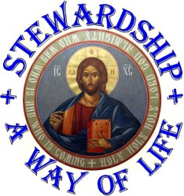
A Note on Christian Stewardship ……..
Life is given to us through Our Lord Jesus Christ. Our commitment to expressing gratitude for this great blessing is seen through our participation in Christian Stewardship by being faithful stewards of The Gospel. Our commitment reveals how we live our faith in the Resurrected Lord. It is in The Resurrection of Our Lord that we receive eternal life and we express our hope in the life to come by our response as Orthodox Christian stewards.
Come and See how we are all called to be Stewards of The Church!
Please take a moment to reflect upon what God has given us, and to discern how we might be able to return to God a portion of the blessings we have received.
Thank you for your continued support and generosity.
May God continue to bless and guide you and keep you always in His Loving Care!

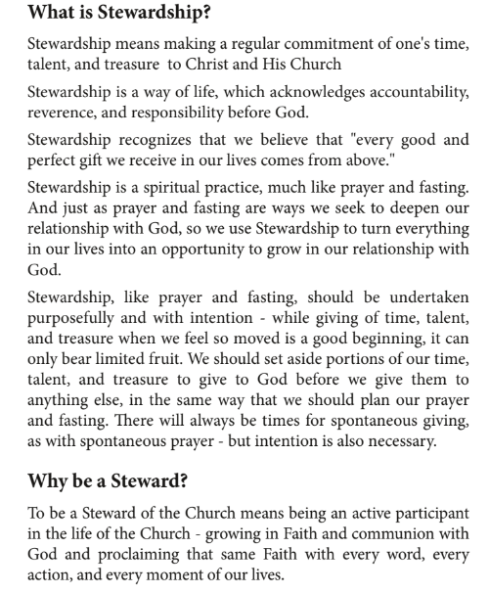

What is Orthodox Christian Stewardship

"It is by offering our blessings back to God that He will be able to continue His forgiving, healing, liberating, empowering, transfiguring, loving ministry through the Church. For God, Infinite though He be, has chosen to work through us, through our gifts, to continue His saving work in the world today." - Fr. Anthony Coniaris

Stewardship reminds us that everything we have has been given to us by God - not for us to have, but for us to care for as stewards, or caretakers. This is why we call those who are actively living the Orthodox Christian life "stewards," because to live the Orthodox Christian life fully means to recognize that we have received everything from God, and therefore we offer some of what we have received back in thanksgiving.

Financial stewardship is an offering, and it is part of how we participate in the saving work of Christ and His Church. By offering back some of what has been given to us, we allow God to work through that offering "for the life of the world." Just as we offer bread and wine for the Liturgy which God transforms into the Body and Blood of Christ to transform us into the living Body of Christ, so do we offer our time, treasure, and talents to Christ and His Church so that God might receive them and transform them into the means not only of our salvation, but for all Creation.

** WEEKLY DIVINE SERVICES AND EDUCATION CLASSES**

TUESDAY MORNINGS
Daily Matins - 9:00 AM

WEDNESDAY EVENINGS
Paraklesis Service to The Theotokos - 6:00 PM

THURSDAY MORNINGS
Akathist or Moleben Prayer Service - 9:00 AM

EVERY OTHER TUESDAY
Catechism/Adult Education Class - 6:30 PM
(via Zoom)

EVERY OTHER TUESDAY
St. George Bible Study Class - 6:30 PM
(via Zoom)

EVERY OTHER MONDAY
St. George Book Club - 6:30 PM
(via Zoom)

EVERY 3RD THURSDAY OF THE MONTH
St. George Prayer Group – 6:30-7:30 PM

WEEKLY EDUCATION VIDEOS ("Q&A with FR. JAY)
and DAILY PASTORAL MESSAGES

THE MONTHLY SCHEDULE FOR NOVEMBER 2023
NOVEMBER 2022{Nativity Fast Begins: Nov. 15-Dec. 24}
PENNIES FOR HEAVEN CHILI/SOUP COOK-0FF/TRUNK OR TREAT FESTIVAL
The Month of November Sunday November 12

- Collection for Health Kit Collection for Mats for Mission WNY
- Start Collection for Christmas Gifts for Baker Victory
- Start Christmas Cookie Collection for Hearts for Homeless
- Start Food Collection for FeedMore of WNY

15 – {Nativity Fast Begins: Nov. 15-Dec. 24}

18 – Annual Prayer Service for Blessing of Animals – 10:00 AM

20 –Eve of the Great Feast of the Entrance of the Theotokos into the Temple
Great Vespers – 4:00 PM

21 – The Great Feast of the Entrance of the Theotokos into the Temple
Festal Divine Liturgy at 9:00 AM

21 – Thanksgiving Prayer Service – 6:30 PM

24 – THANKSGIVING DAY
Moleben Service of Thanksgiving – 9:00 AM

**Education Sermon on Sunday November 26**

27 – Monthly Community Healing Prayer Service at 6:30 PM

++++++++++++++++++++++++++++++++++++++++++++++++++++++++

THE BELOW CLASSES WILL BE HELD VIA ZOOM

**Bible Study Class – Tuesday November 14&28
**St. George Prayer Group– Thursday November 16
**Adult Education Class – Tuesday November 21
++++++++++++++++++++++++++++++++++++++++++++++++++++++++

**PLEASE REFER TO THE WEEKLY EMAILS AND PARISH WEBSITE
FOR CHANGES TO THE CALENDAR!**
ST. GEORGE ORTHODOX CHURCH 2023 NATIVITY PARISH OUTREACH MINISTRY

Once again, this year, as part of our parish outreach ministry during The Nativity Fast and Nativity Christmas Season, we are holding collections for the following Ministries within our Greater Buffalo Area:

- Baker Victory – Christmas Gifts for Children (a list will be sent out next week with information and list of Christmas Gifts for the Children)

Please bring the Christmas Gifts to Church no later than Sunday December 10th and place them in the bin located in the Parish Fellowship Hall.

- Mats for A Mission– Health Kits are given to the individuals on a monthly basis when leaders from The Mats for Mission go downtown and pass out rest mats, food, and other personal and hygiene products to those in need

Please bring the Health Kits to Church no later than Sunday December 10th and place them in the bin located in the Parish Fellowship Hall1

- Hearts for Homeless – Christmas Cookies and Canned Goods/Non-Perishable Items
Please bring the Christmas Cookies and Non-Perishable Items/Canned Goods to Church no later than Sunday December 10th and place them in the bin located in the Parish Fellowship Hall.

- Feed More of WNY - Non-Perishable Food Items and Canned Goods and New Pairs of Winter Gloves (all sizes)

Please bring the Winter Gloves to Church no later than Sunday December 10th and place them in the bin located in the Parish Fellowship Hall.

ST. GEORGE ORTHODOX CHURCH PARISH CHRISTMAS CARD 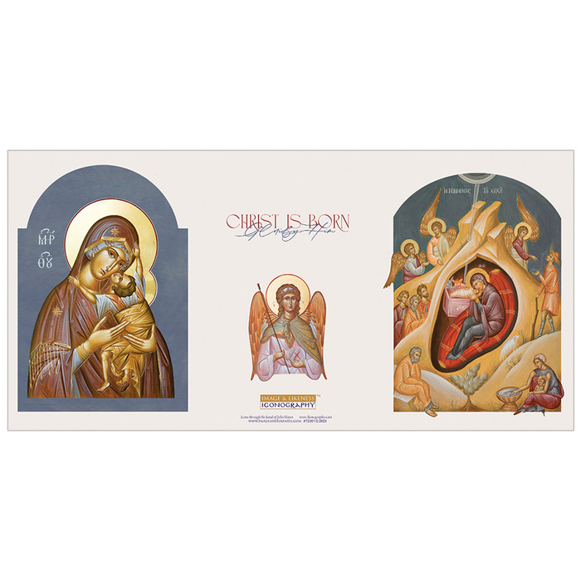
Continuing with our Annual Parish Tradition with the sending of a Parish Christmas Card, we come to all of you – our dear Parish Family for your support in bringing the Love and Joy of Our Lord God and Savior Jesus Christ to everyone during this Holy Season. The cost is only $20 per family.

If we would like to have our name in the Christmas Card, please fill out the attached form with how we would like our name to appear in the card and hand it in to Barbara Kuvshinoff no later Sunday December 10 along with your payment of $20.00. Besides our names, we will also have a Nativity Message and Greeting from our parish family.

If anyone has any questions, please do not hesitate to contact myself (716) 875-4222 / jvansuch@hotmail.com or Barbara (716-553-5722 / barbara.kuvshinoff@gmail.com)

++++++++++++++++++++++++++++++++++++++++++

ST. GEORGE ORTHODOX CHURCH PARISH CHRISTMAS COOKIE TRAY SALE



St. George Orthodox Church

Annual Holiday Christmas Cookie Tray Sale

Sunday, December 17, 2023
12:00-2:00 pm
Parish Fellowship Hall
Corner of Nottingham Terrace and Amherst Street

Christmas Cookie Trays ~ Christmas Basket Raffle

Visit our St. George Bookstore featuring items
for sale from the Orthodox Church and for great Christmas Gifts!

3 dozen Homemade Cookies for $25/tray
~~ ONLY 40 TRAYS AVAILABLE ~~
Pre-Paid Orders Only are due by Sunday December 10, 2023
Cookies are are due by Friday December 15, 2023

COOKIE TRAYS MAKE GREAT GIFTS FOR FAMILY, FRIENDS, CO-WORKERS! DON'T WANT TO BAKE THIS YEAR? MAY NOT HAVE ENOUGH TIME TO BAKE THOSE DELICIOUS CHRISTMAS COOKIES? THEN LET US DO THE BAKING FOR YOU!! NOT ONLY WILL WE RECEIVE DELICIOUS HOMEMADE CHRISTMAS COOKIES BUT ALSO WE WILL SUPPORT THE LIFE, MISSION, AND GOOD WORK OF OUR BELOVED PARISH OF ST. GEORGE!

If we would like to order a Christmas Cookie Tray, please see or contact Mat. Fran (610-698-1666)/fances.vansuch@yahoo.com as well as fill out the attached form and hand it in with payment by Sunday December 10. Tickets for the Basket Raffle will be on sale beginning Sunday November 12 and go through Sunday December 17 with the drawing being held on Sunday December 17!

++++++++++++++++++++++++++++++++++++++++++

2023 POINSETTIA SALE SIGN-UP SHEET


We are once again looking for donations for our Christmas Poinsettias to adorn and decorate our church during The Nativity Season. We will be ordering 20 Poinsettias this year.

ALL POINSETTIAS ARE A $15.00 DONATION! PLEASE MAKE CHECKS OUT TO ST. GEORGE ORTHODOX CHURCH
(Memo Line: Poinsettia Sale)

PLEASE SEE MARY MELLAS FOR PAYMENT and TO SUBMIT FORMS (SEE ATTACHMENT WITH THIS EMAIL) ORDERS ARE DUE BY SUNDAY DECEMBER 17!

WHEN SUBMITTING FORM, PLEASE FILL OUT THE NAMES OF OUR LOVED ONES (HEALTH and DEPARTED) TO BE REMEMBERED DURING THE FESTAL DIVINE LITURGY ON THE GREAT FEAST OF THE NATIVITY OF OUR LORD ON CHRISTMAS MORNING AT 9:30 AM!

IF ANYONE HAS ANY QUESTIONS,
PLEASE SEE MATUSHKA FRAN OR MARY MELLAS!
We extend our sincere and heartfelt thanks and appreciation to all of you and your families for your continued prayers and support.

May GOD continue to bless us and guide us as we grow together in faith and in love as we prepare ourselves to celebrate the Joyous Feast of the Nativity of Our Lord GOD and Savior Jesus Christ!

**POINSETTIAS WILL BE AVAILABLE FOLLOWING
THE FESTAL DIVINE LITURGY ON CHRISTMAS DAY – DECEMBER 25!!




Basket Raffle Tickets can be purchased for $2/each or 3 for $5!

Drawing will be held on Sunday December 17, 2023.
You do not have to be present to win!!

Thank you for your support and generosity
for the continued mission and ministry of our parish!

May God continue to bless you and guide you!



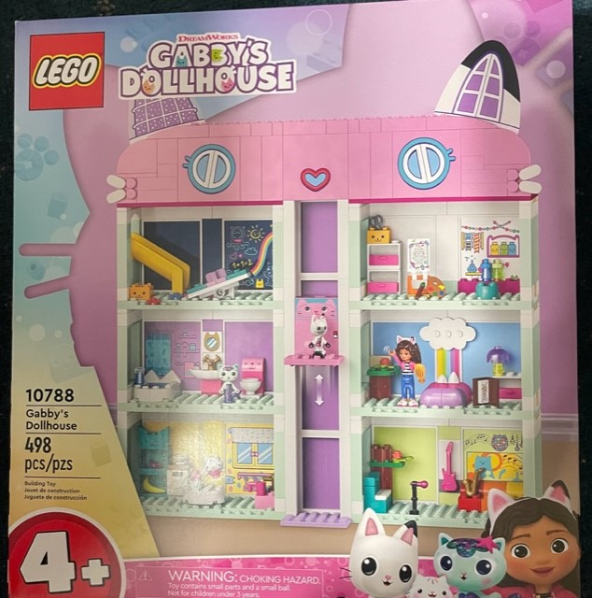

These are Special Basket Raffles Items!

Tickets can be purchased for $5/each!

Drawing will be held on Sunday December 17, 2023.
You do not have to be present to win!!

Thank you for your support and generosity
for the continued mission and ministry of our parish!

May God continue to bless you and guide you!

ANNUAL PARISH MEETING UPDATE

In discussion with Dr. Boris and in consultation with the Parish Council, it has been decided to postpone our Annual Parish Meeting schedule for Sunday November 12 to now be held on Sunday December 10.

This will give the Parish Council more time to make the proper preparations for our meeting. We apologize for any inconvenience with our planning and scheduling. We appreciate your patience and understanding.

With this in mind, the schedule for Sunday December 10 will be as follows:

Matins - 8:45 AM
Divine Liturgy - 9:30 AM
Brief Coffee Hour in Parish Fellowship Hall
2023 Annual Parish Meeting (in The Church) - 11:30/11:45 AM

All reports and information for our Annual Parish Meeting will be sent out to everyone the week before our meeting so that we can all have a chance to review them and prepare ourselves for the meeting. If anyone has any questions or concerns, please do not hesitate to let me know.

On behalf of the Parish Council, I express my thanks and appreciation for your understanding.

Thank you for your support and generosity
for the continued mission and ministry of our parish!

May God continue to bless you and guide you!

