**IMPORTANT ANNOUNCEMENT ABOUT CONFESSION AND HOLY COMMUNION**

**Until further notice, we will continue celebrating the Divine Services up to no more 33 parishioners in attendance. With this in mind, if single parish members or parish member households - UP TO 33 PEOPLE IN CHURCH and 30 PEOPLE IN THE PARISH HALL AT EACH DIVINE LITURGY - would like to attend the Divine Liturgy on a Sunday please refer to the following signup link https://signup.com/go/AqSQSmX ** (Slots 1-30 in the Church and Slots 34-63 in the Parish Hall)! PLEASE SIGN-UP BY SATURDAY NIGHT!!
Regarding Holy Communion:
  - If anyone would like to come and receive Holy Communion or if you would like Fr. Jason to come and bring Holy Communion to your home, please contact him to make arrangements: jvansuch@hotmail.com/609.851.3811/716.875.4222

Regarding Holy Confession:
Taking into consideration the spiritual and mental healing that comes through the Sacrament of Confession, His Eminence blesses, for all priests and communities in the Diocese of New York and New Jersey, that for this period:

- Confession may continue to be held over the telephone or by live video communication; it may also be done in person with social distancing kept between the priest and the penitent (6 feet), and with face masks worn by both. The Prayer of Absolution can be given by video or phone and especially in person.
- When Confession is heard over the telephone or by live video, the priest must read the Prayer of Absolution before ending the phone call or video communication, in the hearing of the penitent.
  - If anyone would like to have Confession, please contact Fr. Jason to make arrangements: jvansuch@hotmail.com/609.851.3811/716.875.4222

+++++++++++++++++++++++++++++++++++++

Please look up the below weblink for the Digital Edition of The Jacobs Well:
https://issuu.com/jacobswell/docs/jacobs-well-fall-2019-nk

Please look up the below weblink for the website of The Diocese of New York and New Jersey:
https://www.nynjoca.org

Please look up the below weblink for the newly-updated Diocesan Directives of The Diocese of New York and New Jersey for the Gradual Approach of Re-Opening of our Parishes:

https://www.nynjoca.org/files/2020/covid-19/Diocesan-Directives-on-the-Gradual-Re-Opening-of-Diocesan-Churches-2020-05-08-For-Distribution.pdf
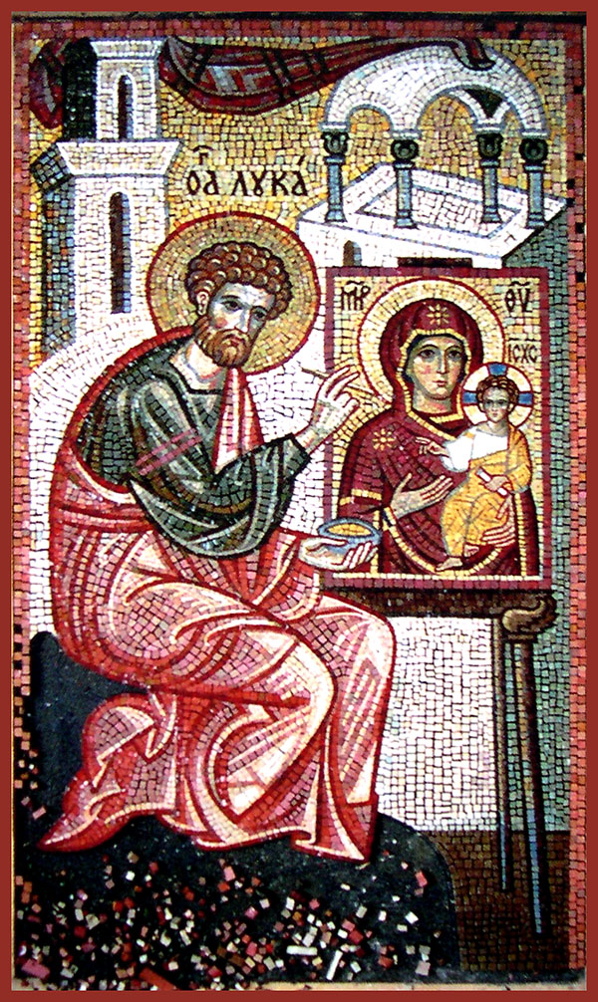

St. George Orthodox Church
2 Nottingham Terrace - Buffalo, NY 14216
(716) 875-4222

www.stgeorgebuffalo.com

NO.371 OCTOBER 18, 2020 ________________________OCTOBER 18, 2020 NO.371
THE WEEKLY MESSENGER

Published weekly in the interest of the parishioners and friends
of Saint George Orthodox Church, Buffalo, NY
a parish of the Diocese of New York and New Jersey
and The Orthodox Church in America

ST. GEORGE ORTHODOX CHURCH

2 Nottingham Terrace Buffalo, NY 14216

V. Rev. Jason Vansuch, Parish Priest

2 Nottingham Terrace 716-875-4222 Buffalo, NY 14216

Cell Phone: 609-851-3811 Email: jvansuch@hotmail.com
Presbyter Andreja Damjanovski, Attached Rev. Peter Irfan, Attached
Reader John Kirwan, Choir Director
Mr. Amil Slaiman, Parish Council President
Home: 716-773-2961 Email: aslaiman2014@gmail.com
19th SUNDAY AFTER PENTECOST — Tone 2. Holy Apostle and Evangelist Luke (1st c.). Martyr Marinus the Elder at Anazarbus (4th c.). Ven. Julian the Hermit, of Mesopotamia (4th c.).

EPISTLE: Liturgy of St. John Chrysostom GOSPEL:
2 Corinthians 11:31-12:9 Luke 8:5-15
Colossians 4:5-9, 14, 18 Luke 10:16 21
_______________________________________________________________________________________
__________________________________________________________________________________________________________________________________________________________________________________________________________________________________________________________________________________________________________________________________________________________________________________________________________________________________________________________________________________________________________________________________________________________________________________________________________________________________________________

GLORY TO JESUS CHRIST! GLORY FOREVER!
_____________________________________________________________________________

**FLOWERS FOR THIS WEEK**
In front of the Icon of Our Lord, In front of the Icon of The Theotokos,
and on the Center Icon Table are donated by Bonnie Dan

+++++++++++++++++++++++++++++++++++++++++++
Altar Vigil Candles are offered by Anthony DelNuovo in Loving Memory
of Thy Servant of God – Frank. May his memory be eternal.
+++++++++++++++++++++++++++++++++++++++++++

TODAY’S WEEKLY MESSENGER IS SPONSORED BY:
ST. GEORGE ORTHODOX CHURCH
_____________________________________________________________________________
WELCOME TO ST. GEORGE ORTHODOX CHURCH
We welcome all of you to the Divine Liturgy this morning, especially those who are visiting with us here at St. George Orthodox Church. Everyone is invited to the Parish Fellowship Hall following the Divine Liturgy for Christian Fellowship. It is our prayer that your experience this morning was spiritually uplifting and you will return very soon to pray with our parish family. In the Orthodox Church, we do not practice open Communion. However we do invite everyone to come and participate in the Divine Liturgy. Hence only those Orthodox Christians who have properly prepared themselves through prayer and fasting may receive Holy Communion. May the Lord bless you with many years of good health and happiness.
THE SCHEDULE OF WEEKLY SERVICES and ACTIVITIES
Sunday October 18, 2020
9:10 A.M. The Third and Sixth Hours
9:30 A.M. Divine Liturgy

Memorial Litia for Thy Servant of God -Boris Kuvshinoff (Dr. Boris’s Father) on the 6th Year Anniversary of his falling asleep in The Lord

Coffee Hour Fellowship following The Divine Liturgy

Church School Classes (via Zoom) 12:30 to 1:15 P.M.

Monday October 19, 2020
7:00-8:30 PM St. Georg Bible Study Class (Via Zoom)

Tuesday October 20, 2020

9:00 A.M. Daily Matins

Wednesday October 21, 2020

6:00 P.M. Paraklesis Service to The Theotokos

Thursday October 22, 2020
9:00 A.M. Akathist Service to St. George

Saturday October 24, 2020

4:00 P.M. Great Vespers

Sunday October 25, 2020
9:10 A.M. The Service of General Confession
9:30 A.M. Divine Liturgy

Coffee Hour Fellowship following The Divine Liturgy

Church School Classes (via Zoom) 12:30 to 1:15 P.M.

* * * * * PRAYERFUL REMEMBRANCE * * * * *
PLEASE REMEMBER TO KEEP IN OUR DAILY PRAYERS
FOR THE HEALTH OF THY SERVANTS:
HIERARCHS
Metropolitan THEODOSIUS Metropolitan HERMAN
CLERGY
Archpriest Herman, Matushka Cynthia and George {Schick} Archpriest James and Mat. Patricia (Mason)
Archpriest Alexey (Karlgut) Archpriest Vladimir and Matushka Jeanne
Archpriest Timmothy/Mat. Michelle Archpriest Michael and Mat. Valerie (Hatrak)
Archpriest Ken and Matushka Natalie (Starevsky) Dn. Sean and Mat. Heather (McNulty)
Archpriest Gregory and Mat. Diane (Winsky) Priest Peter and Mat. Mary (Irfan)
MATUSHKI Presit Andreja and Popadija Anica and Family Presbyter John and Presbytera Nancy
Mat. Katia Mat. Paraskeva Mat. Joanna Popadia Vicki Mat. Christine Mat. Patricia (Severeno)
Mat. Gloria (Martin)
Family/Friends/Parishioners of St. George Orthodox Church Olga, Damian, Cate, Michael, Judy, David
Catherine Ivan/Marina/Inna Bonnie/Michael (Dan) Karen Aliscia (Nick Rostko)
Edwina Irene Luba Jim, Darren, Marsha (Relatives of Elaine M.)
Serena Lillian Reader Victor Andrew/Nicholas (Wityk) William, Natalie, Natasha
Sarah Albert (Fadell) Carol (Frank’s friend) Boris (Kuvshinoff)
Xenia, Justin, Danielle (Friends of Fr. Jason) Frank Oscar Candice, Ronald (Masset)
Victor (Tita Nephew) Catherine (Tony) Susan (Kirwan) June (Pavlov)
Evelyn (Friend of Julie) Billy (William – Mat. Christine’s cousin) Allison (school)
Mary (Massey) Holly Svetlana (Family friend of Fr. Jason/Mat. Katia)
Jeanne (Mat. Christine’s Friend) Angela, Jason, Michelle (Relatives of Dn. Mark) Anthony
Linda Justin (Slaiman) Margaret, Thomas, Victoria (Ewing) Ashley (Friend from Roswell)
Melody Lee, Bridget (John Kirwan friend) Anne (Barbara K. Mother)
Kelly, Robert, Boris, Zaeb, Tirza, Sabas Sada Thlisinitsa, Gemmal, Geesa, and Patric (Fr. Peter)
Jeremy Stewart (nephew of Bill George) Susan (Zumba) Anne (Grandmother of Mariami)
Juliana (Matusiak) Susan (Deeb) Justin (Cmunt) Louis (cousin of Barbara) Yuri/Elena Carol/Maggie Jaime (Zumba) Vera (grandmother of Hannah) Rosemary Harry (neighbor of Tom and MaryAnne Slaiman) Emma/Alexander (relatives of Natalie Huett) Rebecca, Brian
Robert (Bonnie Valieff father) Aspasia (Dean’s Mother) Charles Seraphim Barbara (Rdr. John’s Sister in Law)
Olga (Friend of Fr. Jason/Mat. Katia) Vadym Iryna Yuriy Anastasia Noah (McEntee) Elias, John, Joseph
Mary, Hal, Autumn, Ariana, and Amber, Douglas Judithann (Friend of Barbara) Steven (Uncle of Dean)
Diocese of NY&NJ Prayer List William (Friend of John and Gretchen) Natalie (Huett)
Protopresbyter Leonid (Kishkovsky) Archpriest Paul Archpriest Samuel (Kedela)
Archpriest George (Hasenecz) Archpriest Paul (Shafran) Alonzo (Mat. Jeanne Father)
Archpriest Jonathan (Ivanoff) Archpriest Paul (Kucynda) Matushka Mary (Shafran)
Archpriest Sergei and Mat. Gerry (Glagolev) Priest Vasili (Dubee) John, Michael , Natasha, Marie
Expectant Mothers Helen Moses, Aaron, Sara
Those Serving in The Armed Forces Catechumens
Kenneth, Nadine, Jason, Robert, Andrew, Justin, Shawn, John, Austin, Daniel Juanita Martha,
FOR THY DEPARTED SERVANTS OF GOD:
All of the clergy and parishioners of This Holy House who have departed this life, who now lie asleep in the Lord.
Ever-Memorable Archpriest Eugene Vansuch Ever-Memorable Archpriest George Timko
Ever-Memorable Priest John Bohush Ever-Memorable Archpriest George Aswad
Ever-Memorable Archpriest Rastko Matushka Dorothy (Timko)
Ever-Memorable Dn. Mark
Ever-Memorable Pdn. Gregory Akhtar Remyat, and Barkat (Family of Fr. Peter)
Newly-Departed Servants of God Ever-Memorable Sbdn. Gregory
Matushka Anastasia (Karlgut) (40th Day – October 3) Patrick (Nephew of Rdr John Kirwan)
Mika (Matushka Katia Great-Aunt)
*If anyone would like to have their loved ones added to the prayer list
for remembrance during the Divine Liturgy, please see or contact Fr. Jason.

HYMNS FOR THE DIVINE LITURGY

Troparion for The Resurrection – Tone 2
When Thou didst descend to death, O Life immortal, Thou didst slay hell with the splendor of Thy Godhead. And when from the depths Thou didst raise the dead, all the powers of heaven cried out:// “O Giver of life, Christ our God, glory to Thee!”

Troparion for The Holy Apostle and Evangelist Luke – Tone 5
Let us praise with sacred songs the holy Apostle Luke, the recorder of the joyous Gospel of Christ and the scribe of the Acts of the Apostles; for his writings are a testimony of the Church of Christ. He is the physician of human weaknesses and infirmities. He heals the wounds of our souls,// and constantly intercedes for our salvation.

Kontakion for The Resurrection – Tone 2

Hell became afraid, O almighty Savior, seeing the miracle of Thy Resurrection from the tomb! The dead arose! Creation, with Adam, beheld this and rejoiced with Thee,// and the world, my Savior, praises Thee forever.
Glory to the Father, and to the Son, and to the Holy Spirit.

Kontakion for The Holy Apostle and Evangelist Luke – Tone 2

Let us praise the godly Luke; he is the true preacher of piety, the orator of ineffable mysteries and the star of the Church, for the Word, Who alone knows the hearts of men,// chose him, with the wise Paul, to be a teacher of the Gentiles!
Now and ever and unto ages of ages. Amen.

Steadfast Protectress Tone 6 (Hymn to the Theotokos)
Steadfast Protectress of Christians, constant advocate before the Creator. Despise not the entreating cry of us sinners, but in Your Goodness come speedily to help us who call on You in faith! Hasten to hear our petition and to intercede for us, O Theotokos!! For You always protect those who honor You!

PROKEMEINON Tone 2
The Lord is my strength and my song; / He has become my salvation.
v: The Lord has chastened me sorely, but He has not given me over to death.

THE SECOND PROKEMEINON Tone 8
Their proclamation has gone out into all the earth, / and their words to the ends of the universe!

ALLELUIA VERSES

May the Lord hear thee in the day of trouble! May the name of the God of Jacob protect thee!
Save the King, O Lord, and hear us on the day we call!
The heavens will praise Thy wonders, O Lord; and Thy truth in the congregation of the saints.

THE HYMN TO THE THEOTOKOS

It is truly meet to bless You, O Theotokos, ever blessed and most pure and the Mother of our God. More honorable than the Cherubim and more glorious beyond compare than the Seraphim. Without defilement, You gave birth to God the Word, true Theotokos, we magnify You!

COMMUNION HYMN
Praise the Lord from the heavens, praise Him in the highest! Their proclamation has gone out into all the earth, and their words to the ends of the universe! Alleluia, Alleluia, Alleluia!

EPISTLE LESSON FOR TODAY

2 Corinthians 11:31-12:9 and Colossians 4:5-9, 14, 18 (St. Luke)

Brethren:

The God and Father of our Lord Jesus Christ, who is blessed forever, knows that I am not lying. In Damascus the governor, under Aretas the king, was guarding the city of the Damascenes with a garrison, desiring to arrest me; but I was let down in a basket through a window in the wall, and escaped from his hands.

It is doubtless not profitable for me to boast. I will come to visions and revelations of the Lord: I know a man in Christ who fourteen years ago – whether in the body I do not know, or whether out of the body I do not know, God knows – such a one was caught up to the third heaven. And I know such a man – whether in the body or out of the body I do not know, God knows – how he was caught up into Paradise and heard inexpressible words, which it is not lawful for a man to utter.

Of such a one I will boast; yet of myself I will not boast, except in my infirmities. For though I might desire to boast, I will not be a fool; for I will speak the truth. But I refrain, lest anyone should think of me above what he sees me to be or hears from me. And lest I should be exalted above measure by the abundance of the revelations, a thorn in the flesh was given to me, a messenger of Satan to buffet me, lest I be exalted above measure. Concerning this thing I pleaded with the Lord three times that it might depart from me. And He said to me, “My grace is sufficient for you, for My strength is made perfect in weakness.” Therefore most gladly I will rather boast in my infirmities, that the power of Christ may rest upon me.

Brethren:

Walk in wisdom toward those who are outside, redeeming the time.
Let your speech always be with grace, seasoned with salt, that you may know how you ought to answer each one. Tychicus, a beloved brother, faithful minister, and fellow servant in the Lord, will tell you all the news about me. I am sending him to you for this very purpose, that he may know your circumstances and comfort your hearts, with Onesimus, a faithful and beloved brother, who is one of you. They will make known to you all things which are happening here. Luke the beloved physician and Demas greet you.

This salutation by my own hand – Paul. Remember my chains. Grace be with you. Amen.

GOSPEL LESSON FOR TODAY

Luke 8:5-15 and Luke 10:16-21 (St. Luke)

Let us Attend!

“A sower went out to sow his seed. And as he sowed, some fell by the wayside; and it was trampled down, and the birds of the air devoured it. Some fell on rock; and as soon as it sprang up, it withered away because it lacked moisture. And some fell among thorns, and the thorns sprang up with it and choked it.
But others fell on good ground, sprang up, and yielded a crop a hundredfold.” When He had said these things He cried, “He who has ears to hear, let him hear!”

Then His disciples asked Him, saying, “What does this parable mean?”
And He said, “To you it has been given to know the mysteries of the kingdom of God, but to the rest it is given in parables, that ‘Seeing they may not see, And hearing they may not understand.’

Now the parable is this: The seed is the word of God. Those by the wayside are the ones who hear; then the devil comes and takes away the word out of their hearts, lest they should believe and be saved. But the ones on the rock are those who, when they hear, receive the word with joy; and these have no root, who believe for a while and in time of temptation fall away.

Now the ones that fell among thorns are those who, when they have heard, go out and are choked with cares, riches, and pleasures of life, and bring no fruit to maturity. But the ones that fell on the good ground are those who, having heard the word with a noble and good heart, keep it and bear fruit with patience.

Let us Attend!

He who hears you hears Me, he who rejects you rejects Me, and he who rejects Me rejects Him who sent Me.” Then the seventy returned with joy, saying, “Lord, even the demons are subject to us in Your name.” And He said to them, “I saw Satan fall like lightning from heaven. Behold, I give you the authority to trample on serpents and scorpions, and over all the power of the enemy, and nothing shall by any means hurt you. Nevertheless do not rejoice in this, that the spirits are subject to you, but rather rejoice because your names are written in heaven.”

In that hour Jesus rejoiced in the Spirit and said, “I thank You, Father, Lord of heaven and earth, that You have hidden these things from the wise and prudent and revealed them to babes. Even so, Father, for so it seemed good in Your sight.

=========================================================
= = = Scriptural Readings for the Week = = =

Monday Philippians 2:12-16 Luke 9:18-22
Tuesday Philippians 2:17-23 Luke 9:23-27
Wednesday Philippians 2:24-30 Luke 9:44-50
Thursday Philippians 3:1-8 Luke 9:49-56
Friday Philippians 3:8-19 Luke 10:1-15
Saturday 2 Corinthians 1:8-11 Luke 7:1-10
Sunday Galatians 1:11-19 Luke 16:19-31



A SINCERE AND HEARTFELT THANKS AND APPRECIATION FOR THE FOLLOWING DONATIONS TO THE PARISH FROM OUR
PARISH GIVING TREE

  - Matushka Fran for donating Hand Sanitizer

  - The Thanos Family for donating Liturgical Charcoal

  - Drew and Molly for donating Liturgical Incense

  - Fr. Jason/Mat. Katia/Anna and Alex for donating cups for Zapifka

  - Dr. Boris and Barbara Kuvshinoff for donating the Flowers for The Feast of the Entrance of The Theotokos into The Temple

  - Matushka Christine for donating the Flowers for The Feast of the Universal Exaltation of The Precious and Life-Giving Cross of Our Lord

  - Reader John and Sue Kirwan for donating Liturgical Wine

Please be sure to check out “The Giving Tree” in the Parish Fellowship Hall to see how we may be able to donate towards the needs of our parish through our continued support and stewardship for our beloved parish.

If anyone has any questions, please see or contact Fr. Jason or Barbara.

Thank you for your continued prayerful support and stewardship.

May God continue to bless and guide all of you, your families and our entire parish family and keep all of us in His Loving Care today and always.

LIVE-STREAMING OF DIVINE SERVICES

As a friendly reminder, ALL DIVINE SERVICES, WILL ALSO BE LIVE-STREAMED from Fr. Jason’s Facebook page and our Parish Youtube Page so that we can still be together and pray together. So please continue to join us in prayer!! There are three ways you can join us in prayer via Live-Stream even if we do not have a FaceBook account:

- Go directly to our Parish Website (www.stgeorgebuffalo.com) and on our homepage you will see a a box that says ‘Restream: Stream currently offline”. When ‘live-stream’ is active, the live video will automatically appear.

- Go directly to Fr. Jason’s Facebook Page
https://www.facebook.com/jason.vansuch
and there you will see the Live-stream video.

- Go directly to our Parish Youtube Page
https://www.youtube.com/channel/UCft4AWAX2COrLZExfMJc5KQ
and there you will see the Live-stream video.

+++++++++++++++++++++++++++++++++++++++++++++++++++++++++++++

THOUGHT FOR THE DAY………
We are like stained-glass windows.
We sparkle and shine when the sun is out,
but when the darkness sets in,
our true beauty is revealed only if there is a light from within.

May The Light of Christ Illumine All!

+++++++++++++++++++++++++++++++++++++++++++++++++++++++++++++

Do we have questions about our life, its meaning, purpose, destiny?
Are we desiring to know Jesus Christ, the Son of the living God?
Are we seeking forgiveness, healing, and wholeness?
Do we wonder where to go to find answers?
We can find the answers to these questions and so many other questions
in The Holy Orthodox Church through Her Sacred Tradition,
Holy Scriptures, Her Teachings and Dogmas.

The Orthodox Church is the original Christian Church, the Church founded by the Lord Jesus Christ and described in the pages of the New Testament. Her history can be traced in unbroken continuity all the way back to Christ and His Twelve Apostles, empowered and sent forth on the day of Holy Pentecost. Incredible as it seems, for over twenty centuries she has continued in her undiminished and unaltered faith and practice. Today her apostolic doctrine, worship, and structure remain intact. The Orthodox Church maintains that the Church is the living Body of Jesus Christ. Many of us are surprised to learn that for the first 1000 years of Christian history there was just one Church.

Where is "The Church" to be found and experienced today? Come Taste and See How Good The Lord is every Sunday by joining us for The Divine Liturgy at 10:00 AM.

What is Orthodox Christianity all about? How does it differ from other Christian confessions? This section will attempt to answer these questions and many more.
For a visual introduction to the Orthodox Church, please view the video link below:
http://www.youtube.com/v/Gj4pUphDitA&color1=0xb1b1b1&color2=0xcfcfcf&feature=player_embedded&fs=1” For a brief introduction and in depth study to The Orthodox Faith and to find answers to: ‘What we Believe?” , “Who we Are?”, and “How we Live?’, please view the PDF link below:

http://orthodoxdelmarva.org/files/studies/InquirersClassV1final.pdf
or you may visit the OCA website by clicking the link below:
http://oca.org/orthodoxy/the-orthodox-faith
or you can begin a Journey Through Orthodoxy by clicking the link below:
http://journeytoorthodoxy.com
To learn more ways that we can teach our children about the Orthodox Faith, The OCA has provided a wonderful website for us to use that provides great resources such as (handouts, texts, articles, stories, and much more)! To see this great website, please view the PDF link below:
http://dce.oca.org/page/resources/
If you have any questions or would like to know more about The Orthodox Faith, please contact our parish priest: V Rev. Jason Vansuch (jvansuch@hotmail.com) or 716.875.4222 and he will be able guide you.

IMPORTANT DATES WITHIN THE LIFE OF OUR PARISH

Parish Announcements:
- We will continue with our on-going collections for The Buffalo City Mission, Hearts for Homeless, Mats for Mission, HomeSpace as well as the OCMC Coin Boxes and Health Kits for The Buffalo City Mission.
- WE WILL CONTINUE TO CONTACT ALL OF OUR PARISHIONERS ON A REGULAR BASIS TO ENSURE THAT EVERYONE IS OKAY, SAFE AND HEALTHY.

**Please be on the lookout for emails this week with the following items:
- Reader Vespers for Saturday Evening (October 24)
- Reader Typika Service for Sunday Morning (October 25)
- Information for Bible Study Class – Monday October 19

++++++++++++++++++++++++++++++++++++++++++++++

BEGINNING IN SEPTEMBER, WE WILL BE RECORDING
THE WEEKLY INCOME FOR EACH SUNDAY AS WELL AS OFFERING THE MONTHLY INCOME and EXPENSE FOR OUR PARISH!

INCOME FOR SUNDAY OCTOBER 11, 2020 - $1,378.00
DONATIONS FOR THE NEW BOILER (Capital Improvement Fund) – $1,100.00
Total Donations so far for the New Boiler: $6, 200.00

MAY GOD CONTINUE TO BLESS YOU AND GUIDE YOU FOR YOUR CONTINUED SUPPORT AND PRAYERS!

++++++++++++++++++++++++++++++++++++++++++++++

*Please refer to the Weekly Bulletin and Church Website for any changes to the calendar!*

DAILY FAMILY PRAYER RULE WE CAN PRAY TOGETHER AT HOME WITH OUR FAMILIES

A Prayer Rule must be done in front of the icons and the Gospel in our Icon Corners with a lit candle.. It is important to remember that we must make time for God, for the “Kingdom of heaven suffers violence, and the violent take it by force”(Matt. 11:12).The best time to pray is in the morning or in the evening when we as a family can come together in prayer. Also, when using a Rule of Prayer, we must be flexible and do what we can and do it attentively and consistently. Our goal is to maintain the connection with God and cultivate a real relationship with Him.

With that in mind, please fine below The Rule of Prayer offered by our Diocese for us to use at home especially during this most difficult time when we are not able to be in church together as a parish family.

https://www.nynjoca.org/files/2020/praying-at-home/A-FAMILY-PRAYER-RULE.pdf

May God bless you and keep you always in His Loving Care!
ST. ANDREW'S CAMP

** Saint Andrew's Camp has released a new promotional video for prospective campers!
The video can be found here on Facebook:
https://www.facebook.com/saintandrewsorthodoxcamp/videos/357928144820497/
**Be sure to check it out...you may recognize the priest:)

For more than sixty years, St. Andrew’s Camp has offered the young people of our parishes an incredible summer camping experience. Children and teens have been instructed in prayer and the divine services, the reading of Scripture and the teachings of our Orthodox Church. They have been nourished with the Sacraments of Confession and Holy Communion. They have had fun swimming, horseback riding, playing sports, singing and learning musical instruments, creating in the visual arts, learning to safeguard the planet, and exploring the stars. And they have established friendships that last a lifetime, met their future spouses, and nurtured their vocations to serve the Lord in ministry.

As a token of gratitude for the labors of love extended by the administration and staff, both clergy and laypersons, of St. Andrew’s over the past six decades, it is now time for us to help the Camp in an especially needed way.

Please join us in raising funds for the new multi purpose building which will include new kitchen, dining hall and activities center. The cost of this new building is
$300,000. To become a reality, the completion and furnishing of this much-needed center will require great generosity of individuals, organizations and parishes.

You can click on the link below which will take you to the gofundme.com page.

https://www.gofundme.com/f/st-andrew039s-camp-fundraiser-by-ss-peter-and-paul
As we continue to fulfill the work of Our Lord by living and fulfilling His Gospel Message, let us open our hearts and minds by providing support and assistance to our Diocese, to our children, by taking a moment to reflect upon what God has given us, and to discern how we might be able to return to God a portion of the blessings we have received.

We extend our heartfelt thanks and appreciation to all of you and your families for your continued prayers, support and generosity.
+++++++++++++++++++++++++++++++++++++++++++++++++++++
**Also, make sure we check out the promotional video for prospective campers!
The video can be found here on Facebook:
https://www.facebook.com/saintandrewsorthodoxcamp/videos/357928144820497/

**Be sure to check it out...you may recognize the priest:)

+++++++++++++++++++++++++++++++++++++++++++++++++++++
SPECIAL ANNOUNCEMNET REGARDING ATTENDANCE AT DIVINE LITURGY ON SUNDAYS

With the Blessing and Approval of His Eminence Archbishop MICHAEL, we will be holding an overflow of parishioners in the Parish Fellowship Hall for Divine Liturgy on Sundays.

During the course of the week, we will continue to clean, sanitize and set up the hall with Icons, Candle Stands, Projector, Projector Screen, socially distant seating, stand with masks and hand sanitizer for when we will begin overflow attendance for the Divine Liturgy. We will also continue to clean, sanitize the Altar and Church on a regular basis (before and after every service). This is exciting news, that to the Glory of God and by His Grace, we will be able to allow more of our parishioners to attend the Divine Liturgy on Sundays. If anyone has any questions or concerns, please do not hesitate to let m Fr. Jason know. May God continue to bless and keep all of you in His loving care today and always.

**IF WE WISH TO ATTEND THE DIVINE LITURGY ON SUNDAY MORNINGS, PLEASE SIGN UP BY SATURDAY NIGHT!! HERE IS THE SIGN-UP LINK: https://signup.com/go/AqSQSmX **

Remember our Loved Ones during Our Daily Prayers

‘Assuredly, I say to you, inasmuch as you did it to one of the
least of these My brethren, you did it to Me.’

{Matt. 25:40}

As we say our daily prayers, let us also take time out to remember our loved ones who are homebound, who are in hospitals and who are in nursing homes. Let us remember them that GOD will continue to watch over them and protect them. Also, during the Year, let us take to either send them a card, give them a call, or visit them to let them know how much we love them, how much we remember them, and how much we pray for them.

Please refer to the of our Parish Shut-Ins below.

If anyone has any questions or would like to add someone to our List of Parish Shut-Ins, please see or contact Fr. Jason. May God continue to bless you and guide you!

ST. GEORGE ORTHODOX CHURCH PARISH SHUT-INS (2020)
Mrs. Diane Salvamoser Reader Victor Shanchuk Mrs. Luba Japadjief
147 West Hazeltine Avenue 495 Lafayette Avenue Elderwood Nursing Home (Memory Care Unit)
Kenmore, NY 14217 Buffalo, NY 14222 245 Bassett Road
716.875.9503 716.881.3096 Williamsville, NY (Room 30)

Mrs. Catherine Tony Mrs. Mary Massey
274 Wadsworth Ave. c/o Terrace View Long Term Care (Delaware Park)
Tonawanda, NY 14150 462 Grider Street
716.695.3068 Buffalo, NY 14215

Mr. Albert Fadell Andrew Wityk
317.376.2562 Ellicott Center
200 Seventh Street
Buffalo, NY 14201

WEEKLY VIDEO SERMONS GIVEN BY HIS EMINENCE ARCHBISHOP MICHAEL
These sermons offered to us by The Diocese via video can be found on the Diocesan Website: http://www.nynjoca.org! There are videos for each week beginning with The Feast of Feasts – Holy Pascha! Be sure to check them out!

+++++++++++++++++

An Invitation to Support the Stewards of the OCA!
The Orthodox Church in America (OCA) set the direction for expanding our apostolic work in North America at the 18th All-American Council. The foundation for this work is Jesus Christ, Whom we encounter in our spiritual lives, stewardship, evangelism and outreach, and relations with others as we engage the world. Being a steward of the OCA goes beyond the financial gifts which support the work of our church. Being a steward is about caring for and knowing the history of the mission of the Orthodox Church here in North America and finding your place in that history. Having received this great gift of our Orthodox Faith, we bear the responsibility to continue the legacy of Saint Herman and Saint Tikhon; Saint Innocent and Saint Alexis and all the other saints known and unknown who have worked to build up and expand Christ's Church here in North America. Please consider being a part of that mission today by giving to the Stewards of the OCA. For more information, please visit The OCA Website: https://oca.org/become-a-steward

+++++++++++++++++

An Invitation to Support the Ministry of the DDB!
In order to fund necessary ministries and fulfill the work of the Church in the Diocese of New York and New Jersey, Distinguished Diocesan Benefactors generously contribute financial support. To learn more about the DDB, please go to the following link: http://vimeo.com/71021182 and watch a 60 second video inviting you to join the ever-growing list of Distinguished Diocesan Benefactors of The Diocese of New York and New Jersey who joyfully support the on-going work of our diocese. Their support allows us to provide assistance to new mission parishes, scholarships to seminarians, support the departments of The Diocese, and much-needed encouragement to older struggling parishes. How about you? Our parish is a member of the DDB. If anyone would like to join, please see Fr. Jason as well as take a pamphlet from the table in the back of the church. May God continue to bless and guide you for your continued support. The Diocese of New York and New Jersey has two monthly newsletters: "First Fruits" and "Beyond the Plateau." The goal, as expressed by Archbishop Michael, is to increase communication and grow the communal spirit of diocesan fellowship in the building-up and strengthening of our parish communities. To learn more about these monthly diocesan publications, please refer to the diocesan website: http://www.nynjoca.org/newsletters.html.

+++++++++++++++++
“Lessons in Our Faith” Video presented by His Eminence Archbishop MICHAEL
His Eminence Archbishop Michael presents a series of talks on matters of faith, belief, and the teachings of the Church. These instructional videos are concise and "to the point," offering Orthodox Christians much-needed information, helpful advice for their spiritual journey, and assistance in answering questions that may come from non-Orthodox friends or acquaintances. The goal is that we might better know and better live our faith. These instructional videos can be found at the Diocesan Website: http://www.nynjoca.org! For those who do not have internet, please see the handouts from each lesson which are located on the table in the back of the church. There are 14 videos! Be sure to check them out!

ST. GEORGE ORTHODOX CHURCH BOOKSTORE
As you are in the Parish Fellowship Hall for coffee hour, don't forget to check out our newly-formed Bookstore. We have some new items that just arrived. These items include: Icon ornaments, jewelry, Icons, prayer books, prayers ropes, and much more. If you need a Gift, come check out the Bookstore…you may find something you like!! We are now also offering Gift Certificates for our Bookstore. Please speak with Dave or Andrea for more details/information!! We thank David and Andrea Chmiel who are managing of our Bookstore for us. If you have any questions or if you would like to order something that you do not see, please see or contact David or Andrea Chmiel and they will be able to assist you. You may also email them at: bookstore@stgeorgebuffalo.com. May GOD continue to bless and guide all of you.

ST. GEORGE ORTHODOX CHURCH EDUICATION CORNER

The Holy Apostle and Evangelist Luke

October 18
The Holy Apostle and Evangelist Luke, was a native of Syrian Antioch, a companion of the holy Apostle Paul (Phil.1:24, 2 Tim. 4:10-11), and a physician enlightened in the Greek medical arts. Hearing about Christ, Luke arrived in Palestine and fervently accepted the preaching of salvation from the Lord Himself. As one of the Seventy Apostles, Saint Luke was sent by the Lord with the others to preach the Kingdom of Heaven during the Savior’s earthly life (Luke 10:1-3). After the Resurrection, the Lord Jesus Christ appeared to Saints Luke and Cleopas on the road to Emmaus.
Luke accompanied Saint Paul on his second missionary journey, and from that time they were inseparable. When Paul’s coworkers had forsaken him, only Luke remained to assist him in his ministry (2 Tim. 4:10-11). After the martyric death of the First-Ranked Apostles Peter and Paul, Saint Luke left Rome to preach in Achaia, Libya, Egypt and the Thebaid. He ended his life by suffering martyrdom in the city of Thebes.
Tradition credits Saint Luke with painting the first icons of the Mother of God. “Let the grace of Him Who was born of Me and My mercy be with these Icons,” said the All-Pure Virgin after seeing the icons. Saint Luke also painted icons of the First-Ranked Apostles Peter and Paul. Saint Luke’s Gospel was written in the years 62-63 at Rome, under the guidance of the Apostle Paul. In the preliminary verses (1:1-3), Saint Luke precisely sets forth the purpose of his work. He proposes to record, in chronological order, everything known by Christians about Jesus Christ and His teachings. By doing this, he provided a firmer historical basis for Christian teaching (1:4). He carefully investigated the facts, and made generous use of the oral tradition of the Church and of what the All-Pure Virgin Mary Herself had told him (2:19, 51).
In Saint Luke’s Gospel, the message of the salvation made possible by the Lord Jesus Christ, and the preaching of the Gospel, are of primary importance.
Saint Luke also wrote the Acts of the Holy Apostles at Rome around 62-63 A.D. The Book of Acts, which is a continuation of the four Gospels, speaks about the works and the fruits of the holy Apostles after the Ascension of the Savior. At the center of the narrative is the Council of the holy Apostles at Jerusalem in the year 51, a Church event of great significance, which resulted in the separation of Christianity from Judaism and its independent dissemination into the world (Acts 15:6-29). The theological focus of the Book of Acts is the coming of the Holy Spirit, Who will guide the Church “into all truth” (John 16:13) until the Second Coming of Christ.
The holy relics of Saint Luke were taken from Constantinople and brought to Padua, Italy at some point in history. Perhaps this was during the infamous Crusade of 1204. In 1992, Metropolitan Hieronymus (Jerome) of Thebes requested the Roman Catholic bishop in Thebes to obtain a portion of Saint Luke’s relics for the saint’s empty sepulchre in the Orthodox cathedral in Thebes.
The Roman Catholic bishop Antonio Mattiazzo of Padua, noting that Orthodox pilgrims came to Padua to venerate the relics while many Catholics did not even know that the relics were there, appointed a committee to investigate the relics in Padua, and the skull of Saint Luke in the Catholic Cathedral of Saint Vico in Prague. The skeleton was determined to be that of an elderly man of strong build. In 2001, a tooth found in the coffin was judged to be consistent with the DNA of Syrians living near the area of Antioch dating from 72-416 A.D. The skull in Prague perfectly fit the neck bone of the skelton. The tooth found in the coffin in Padua was also found to fit the jawbone of the skull.
Bishop Mattiazzo sent a rib from the relics to Metropolitan Hieronymus to be venerated in Saint Luke’s original tomb in the Orthodox cathedral at Thebes.
Saint Luke is also commemorated on April 22.

Nineteenth Sunday after Pentecost
The Parable of the Sower

Luke 8:5-15

From The Explanation of the Gospel of St. Luke

by Blessed Theophylact, Archbishop of Ochrid and Bulgaria
4-10. And when many people were gathered together, and were come to Him out of every city, He spake by a parable: a sower went out to sow his seed. And as he sowed, some fell along the way; and it was trodden down, and the winged creatures of the air devoured it. And some fell upon a rock; and as soon as it was sprung up, it withered away, because it lacked moisture. And some fell among thorns; and the thorns sprang up with it, and choked it. And other fell on good ground, and sprang up, and bare fruit an hundredfold. And when He had said these things, He cried, He that hath ears to hear, let him hear. And His disciples asked Him, saying, What might this parable be? And He said, Unto you it is given to know the mysteries of the kingdom of God: but to others in parables; that seeing they might not see, and hearing they might not understand.
What David said of old, speaking prophetically in the person of Christ, has now come to pass: I will open My mouth in parables. [Ps. 77:2] The Lord speaks in parables for many reasons: to make His listeners more attentive and to stir up their minds to seek the meaning of what is said. For we are apt to be curious about sayings that are obscure in meaning and to disregard sayings that are clear. He also speaks in parables so that those who are unworthy may not understand what is said concerning spiritual mysteries. And there are many other reasons why He speaks in parables. A sower, therefore, went out, that is, the Son of God went forth from the Fathers bosom, from the hidden fastness of the Father, and became manifest to all. Who went out? He Who is ever sowing. The Son of God never ceases to sow in our souls. Not only by His teaching, but by all of creation and by the events of our daily lives, He plants good seed in our souls. He went out, not to slay trespassers or to burn off the stubble, but to sow. For there are many reasons why a farmer might go forth, besides to plant. He went out to sow His own seed: the word of teaching was His own, and not another’s. The prophets had spoken, not their own words, but the words of the Holy Spirit. This is why they said, Thus saith the Lord. But Christ had His own seed to sow. When He taught, He did not say, "Thus saith the Lord," but, "I say unto you." As He sowed, that is, as He taught, some seed fell along the road. He did not say that the sower threw the seed along the road, but instead that some fell there. Christ the Sower sows and teaches, and His word falls upon his listeners everywhere, and it is they who show themselves to be like a road, or a rock, or thorns, or good soil. When the disciples ask about the parable, the Lord says, Unto you it is given to know the mysteries of the kingdom of God, that is, unto you who desire to learn, for everyone that asketh, receiveth. [Mt. 7:8] To the others who are not worthy of the mysteries, He speaks obscurely. They think that they see, but they do not; they hear, but they do not understand. And this is to their benefit. The Lord hides these things from them so that they will not fall under greater condemnation for understanding the mysteries and then disregarding them. He who understands, and then disregards, deserves a more severe punishment.
11-15. Now the parable is this: The seed is the word of God. Those along the way are they that hear; then cometh the devil, and taketh away the word out of their hearts, lest they should believe and be saved. They on the rock are they, which, when they hear, receive the word with joy; and these have no root, who for a while believe, and in time of temptation fall away. And that which fell among thorns are they, which, when they have heard, go forth, and are choked with cares of riches and of pleasures of this life, and bring no fruit to perfection. But that on the good ground are they, which in an honest and good heart, having heard the word, keep it, and bring forth fruit with patient endurance.
Here are described three types of those who are not saved. First, there are those along the way, who do not receive and accept the word at all. Just as a pathway, which is well trodden and compacted, cannot receive the seed because it is hard, so also those who are hardened in their hearts do not accept the word at all. Though they hear the word, they give it no heed. Next there are those on the rock who hear the word, and then do not endure temptations because of human weakness, and deny the faith. The third kind are those who hear the word and then are choked by the cares of life. Three parts, therefore, perish, and only one part is saved. Few are saved; most perish. See that it is not said of those who are choked, that they are choked by riches, but rather by the cares of riches. It is not wealth that harms, but the cares and worries about wealth which fill the mind. Indeed, many have received great benefit from their wealth, when they poured it out to feed the poor. Consider the preciseness of the Evangelist, when he says of those who are saved, that when they have heard the word, they keep it, in contrast to those who are along the pathway, who do not keep the word; instead, the devil takes the word from them. And they bring forth fruit, in contrast to those who are choked by the thorns, and who bring no fruit to maturity. In truth those whose fruit never ripens bear no fruit at all. Those who bring forth fruit with patient endurance stand in contrast to those who are on the rock, who receive the word but then do not endure the onslaught of temptations and show that they cannot withstand the test. See how the Evangelist says three things concerning those who are saved, that they keep the word, that they bring forth fruit, and that they do so with patient endurance. By these three statements he distinguishes the saved from those who perish those along the pathway who do not keep the word; those among thorns who bring no fruit to perfection; and those on the rock who do not patiently endure the assault of temptations.

+++++++++++++++++++++++++++++++++++++++++++++++++++

LET ALL THAT YOU DO BE DONE IN LOVE. 1 Cor.16:14

YOU SHALL LOVE THE LORD YOUR GOD WITH ALL YOUR HEART, AND WITH ALL YOUR SOUL, AND WITH ALL YOUR MIND. Matt. 22:37

YOU SHALL LOVE YOUR NEIGHBOR AS YOURSELF. Matt. 22:39

LOVE YOUR ENEMIES AND PRAY FOR THOSE WHO PERSECUTE YOU. Matt. 5:44

LOVE IS PATIENT, LOVE IS KIND, LOVE DOES NOT ENVY, LOVE DOES NOT BOAST, LOVE IS NOT PROUD, LOVE IS NOT SELFISH, LOVE IS NOT PROVOKED. 1Cor. 13:4

LOVE BEARS ALL THINGS, LOVE ALWAYS HAS FAITH, LOVE ALWAYS HAS HOPE, LOVE ENDURES ALL THINGS. LOVE NEVER FAILS! 1Cor. 13:7,8

+++++++++++++++++++++++++++++++++++++++++++++++++++

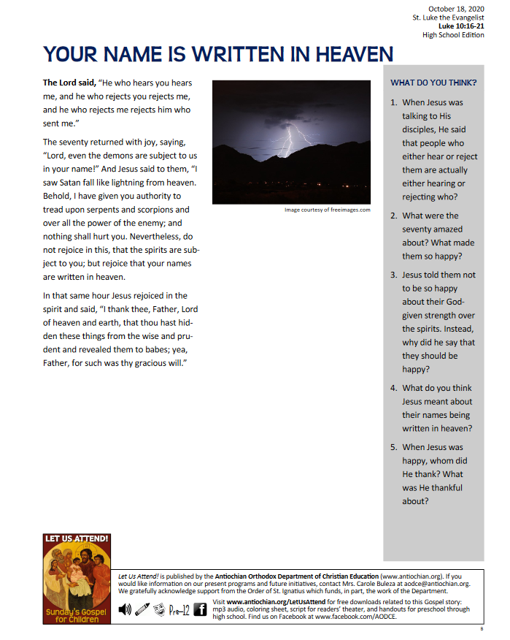

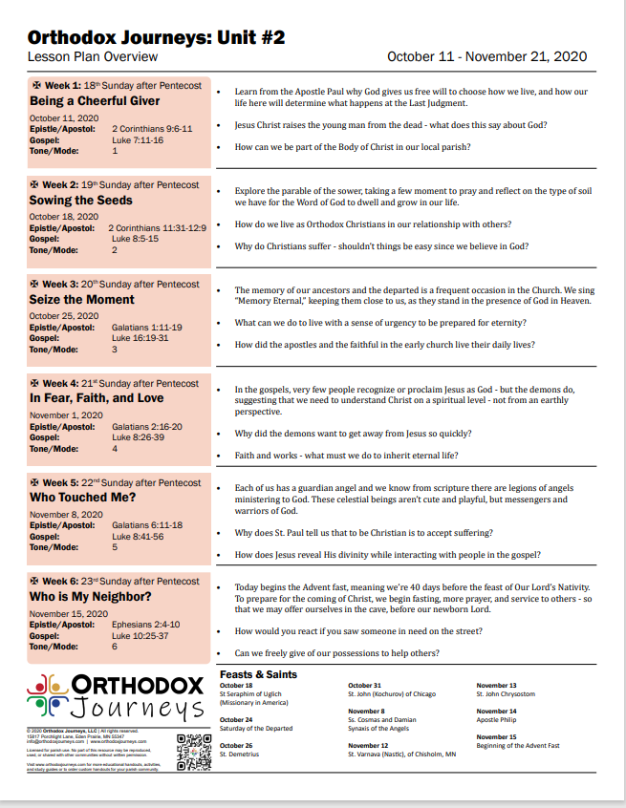

JOIN ARCHBISHOP MICHAEL, TO PRAY AND FAST
FOR RECONCILIATION AND AN END TO CIVIL STRIFE

The clergy and faithful of the Diocese continue to mourn the tragic losses of life, the needless acts of violence, the divisions among races, and the civil strife which plague many of our cities and countrysides.
Our Lord’s own words instruct us as to what our response to injustice, inequality, violence and hopelessness must be: “Whatever you do to the least of My brethren, you do it to Me” (Matthew 25:40), and “by this will all men know that you are My disciples, if you have love for one another” (John 13:15). The Saints remind us that we are blind unless we see every human being – regardless of their differences – as made in the image, and after the likeness, of God (Genesis 1:26-27). And the Sermon on the Mount challenges us to become “peacemakers, for they shall be called the sons of God.”
Rev. Dr. Martin Luther King put it this way, “Darkness cannot drive out darkness; only light can do that. Hate cannot drive out hate; only love can do that. Hate multiplies hate; violence multiplies violence in a descending spiral of destruction.”
The work of establishing justice and equality, and peace and love among all peoples in our country, cannot be achieved by one-time efforts; it must be an ongoing process of change, of repentance. And some kinds of evil, according to our Savior, are only driven out “by prayer and fasting” (Matthew 17:21).
So, I invite all of our diocesan family to join with me in a Year Dedicated to Reconciliation and An End to Civil Strife by praying and fasting on the first day of every month, beginning Wednesday, July 1: by praying the Akathist to the African Saints, and the Prayer for Racial Reconciliation (which is attached to this e-mail) – at 12:00 noon, and abstaining from eating lunch that day.
If you cannot pray and fast at noon on that day, then choose another meal from which to fast, and another time to pray the Akathist … or at least offer the Prayer for Racial Reconciliation, which is at the conclusion of the service, if that is all that you have time to do.
We ask the Lord to help us become instruments of peace and reconciliation … for those who truly pray and fast for this cause, cannot be at the same time instruments of hatred and violence.
May Our Lord bring an end to the strife that divides the people of this country from one another … may He make us instruments of that process … and, may He grant mercy and blessed repose to all those who have been taken from us in acts of hatred and fear. May their memory be eternal.

++++++++++++++++++++++++++++++++++++++++++++++++++

WE WILL GATHER TOGETHER AS A PARISH FAMILY IN PRAYER ON THE FOLLOWING DAYS AT 12:00 NOON AND SERVE “THE PRAYER SERVICE FOR AMERICA”:

Sunday November 1 (After Divine Liturgy)
Tuesday December 1 Friday January 1, 2021 (After Divine Liturgy)
Monday February 1 Monday March 1
Thursday April 1 Saturday May 1
Tuesday June 1

**PLEASE SPREAD THE WORD AND INVITE OUR FAMILIES FRIENDS, NEIGHBORS COME AND PRAY WITH US!

