Do we have questions about our life, its meaning, purpose, destiny?
Are we desiring to know Jesus Christ, the Son of the living God?
Are we seeking forgiveness, healing, and wholeness?
Do we wonder where to go to find answers?
We can find the answers to these questions and so many other questions
in The Holy Orthodox Church through Her Sacred Tradition,
Holy Scriptures, Her Teachings and Dogmas.

The Orthodox Church is the original Christian Church, the Church founded by the Lord Jesus Christ and described in the pages of the New Testament. Her history can be traced in unbroken continuity all the way back to Christ and His Twelve Apostles, empowered and sent forth on the day of Holy Pentecost. Incredible as it seems, for over twenty centuries she has continued in her undiminished and unaltered faith and practice. Today her apostolic doctrine, worship, and structure remain intact. The Orthodox Church maintains that the Church is the living Body of Jesus Christ. Many of us are surprised to learn that for the first 1000 years of Christian history there was just one Church.

Where is "The Church" to be found and experienced today? Come Taste and See How Good The Lord is every Sunday by joining us for The Divine Liturgy at 10:00 AM.

What is Orthodox Christianity all about? How does it differ from other Christian confessions? This section will attempt to answer these questions and many more.
For a visual introduction to the Orthodox Church, please view the video link below:
http://www.youtube.com/v/Gj4pUphDitA&color1=0xb1b1b1&color2=0xcfcfcf&feature=player_embedded&fs=1”

For a brief introduction and in depth study to The Orthodox Faith and to find answers to: ‘What we Believe?” , “Who we Are?”, and “How we Live?’, please view the PDF link below:
http://orthodoxdelmarva.org/files/studies/InquirersClassV1final.pdf
or you may visit the OCA website by clicking the link below:
http://oca.org/orthodoxy/the-orthodox-faith
or you can begin a Journey Through Orthodoxy by clicking the link below:
http://journeytoorthodoxy.com
To learn more ways that we can teach our children about the Orthodox Faith, The OCA has provided a wonderful website for us to use that provides great resources such as (handouts, texts, articles, stories, and much more)! To see this great website, please view the PDF link below:
http://dce.oca.org/page/resources/

If you have any questions or would like to know more about The Orthodox Faith, please contact our parish priest: V Rev. Jason Vansuch (jvansuch@hotmail.com) or 716.875.4222 and he will be able guide you.
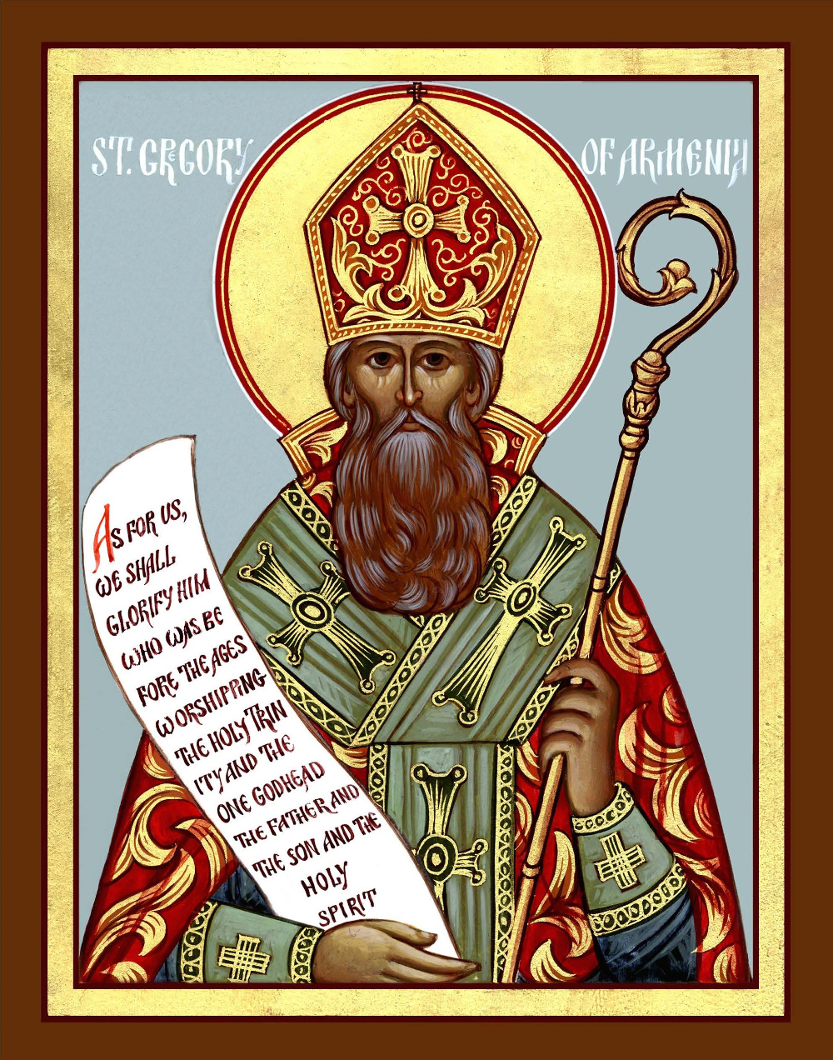

St. George Orthodox Church
2 Nottingham Terrace - Buffalo, NY 14216
(716) 875-4222

www.stgeorgebuffalo.com

NO.267 SEPTEMBER 30, 2018 __________________SEPTEMBER 30, 2018 NO.267
THE WEEKLY MESSENGER

Published weekly in the interest of the parishioners and friends
of Saint George Orthodox Church, Buffalo, NY
a parish of the Diocese of New York and New Jersey
and The Orthodox Church in America

ST. GEORGE ORTHODOX CHURCH

2 Nottingham Terrace Buffalo, NY 14216

V. Rev. Jason Vansuch, Parish Priest

2 Nottingham Terrace 716-875-4222 Buffalo, NY 14216

Cell Phone: 609-851-3811 Email: jvansuch@hotmail.com
Reader John Kirwan, Choir Director
Mr. John Judge, Parish Council President
18th SUNDAY AFTER PENTECOST — Tone 1. Hieromartyr Gregory, Bishop of Greater Armenia (ca. 335). Ven. Gregory, Abbot of Pelshme, Wonderworker of Vologdá (1442). St. Michael, First Metropolitan of Kiev (992). Martyrs Rhipsime, Gaiana and 35 holy virgins with them, of Armenia (4th c.).

EPISTLE: Liturgy of St. John Chrysostom GOSPEL: 2 Corinthians 9:6-11 Luke 6:31-36
_______________________________________________________________________________________
_________________________________________________________________________________________________________________________________________________________________________________________________________________________________________________________________________________________________________________________________________________________________________________________________________________________________________________________________________________________________________________________________________________________________________________________________________________________________________________

GLORY TO JESUS CHRIST! GLORY FOREVER!
_____________________________________________________________________________

**FLOWERS FOR THIS WEEK**
In front of the Icon of Our Lord, In front of the Icon of The Theotokos,
and on the Center Icon Table are donated by ST. GEORGE ORTHDOOX CHURCH
+++++++++++++++++++++++++++++++++++++++++++
Altar Candles are offered by Anthony DelNuovo in Loving Memory
of Thy Servant of God, Frank. May his memory be eternal.
+++++++++++++++++++++++++++++++++++++++++++
TODAY’S WEEKLY MESSENGER IS SPONSORED BY:
ST. GEORGE ORTHDOOX CHURCH
_____________________________________________________________________________

WELCOME TO ST. GEORGE ORTHODOX CHURCH
We welcome all of you to the Divine Liturgy this morning, especially those who are visiting with us here at St. George Orthodox Church. Everyone is invited to the Parish Fellowship Hall following the Divine Liturgy for Christian Fellowship. It is our prayer that your experience this morning was spiritually uplifting and you will return very soon to pray with our parish family. In the Orthodox Church, we do not practice open Communion. However we do invite everyone to come and participate in the Divine Liturgy. Hence only those Orthodox Christians who have properly prepared themselves through prayer and fasting may receive Holy Communion. May the Lord bless you with many years of good health and happiness.
THE SCHEDULE OF WEEKLY SERVICES and ACTIVITIES

SUNDAY SEPTEMBER 30, 2018
The Hours – 9:10 AM General Confession – 9:30 AM
Divine Liturgy– 10:00 AM (Education Sermon)

Church School in Parish Fellowship Hall following Divine Liturgy!
Coffee Hour in Parish Fellowship Hall following Divine Liturgy!
COFFEE HOUR HOST:

St. George Book Club – 5:00 PM (Spot Coffee on Hertel Ave)

MONDAY OCTOBER 1, 2018
FEAST OF THE PROTECTION OF THE THEOTOKOS

Divine Liturgy – 9:30 AM

WEDNESDAY OCTOBER 3, 2018
Daily Matins – 9:00 AM

THURSDAY OCTOBER 4, 2018

Moleben Service to St. George – 9:00 AM

Daily Vespers – 6:30 PM

Introduction of Orthodoxy 101 Class in the Church Fellowship Hall – 7:00 to 8:00 PM

FRIDAY OCTOBER 5-6, 2018

Parish Pilgrimage to The Monastery of Holy Transfiguration (Ellwood City, PA)

SATURDAY OCTOBER 6, 2018

Reader Vespers – 4:00 PM

SUNDAY OCTOBER 7, 2018 (Youth Sunday)
Matins – 9:0 AM Divine Liturgy– 10:00 AM (Children Sermon)
Memorial Litia for The Ever-Memorable Servant of God:
Dn. Mark on the third Anniversary of his falling asleep in the Lord

Church School in Parish Fellowship Hall following Divine Liturgy!
Coffee Hour in Parish Fellowship Hall following Divine Liturgy!
COFFEE HOUR HOST:
* * * * * PRAYERFUL REMEMBRANCE * * * * *
PLEASE REMEMBER TO KEEP IN OUR DAILY PRAYERS
FOR THE HEALTH OF THY SERVANTS:
HIERARCHS
Metropolitan THEODOSIUS Metropolitan HERMAN
CLERGY
Archpriest Herman, Matushka Cynthia and George Archpriest Vladimir and Matushka Jeanne
Archpriest Vincent and Mat. Patricia (Severeno) Priest Peter and Mat. Mary (Irfan)
Archpriest Alexey (Karlgut) and Matushka Anastasia Archpriest Timmothy/Mat. Michelle
Archpriest Ken and Matushka Natalie (Starevsky) Dn. Sean and Mat. Heather McNulty
MATUSHKI Archpriest James and Mat. Patricia (Mason)
Mat. Katia Mat. Paraskeva (Vansuch) Mat. Joanna (Bohush) P opadia Vicki Mat. Christine
Family/Friends/Parishioners of St. George Orthodox Church
Catherine Ivan/Marina/Inna Bonnie (Dan) Karen Aliscia (Nick Rostko)
Edwina Irene Luba Jim, Darren, Marsha (Relatives of Elaine M.)
Serena Lillian Reader Victor Nicholas (Wityk)
Sarah Albert/Helen (Fadell) Carol (Frank’s friend) Boris (Kuvshinoff)
Xenia, Justin, Danielle (Friends of Fr. Jason) Frank Oscar
Victor (Tita Nephew) Catherine (Tony) Susan (Kirwan) June (Pavlov) Evelyn (Friend of Julie) Billy (William – Mat. Christine’s cousin) Allison , Svetlana (Family friends of Fr. Jason/Mat.Katia) James (brother of Bonnie Valieff) Noah (McEntee)
Mary (Massey) Holly Varvara (Mary Jo Mother)
Harry (neighbor of Tom and MaryAnne Slaiman) Charles Seraphim
Jeanne (Mat. Christine’s Friend) Angela, Jason, Michelle (Relatives of Dn. Mark)
Linda (Mucyn) Carol (Mailman’s sister-in-law) Ana (sister of Tita)
Margaret, Thomas (Ewing) Ashley (Friend from Roswell) Justin (Slaiman)
Lee, Bridget (John Kirwan friend) Cory (Friend of Charles) Olga (Olhovsky)
Melody, Kelly, Robert, Boris, Rehmat, Zaeb, Tirza, Sabas Sada Thlisinitsa,
Gemmal, Geesa, and Patric (Fr. Peter) Anne (Mother of Barb Kuvshinoff)
Jeremy Stewart (nephew of Bill George) Susan (Zumba) Vera (grandmother of Hannah)
Susan (Deeb) Justin (Cmunt) Louis (cousin of Barbara K.) Aspacia (Dean’s mother)
Yuri/Elena Thomas, Justin (Slaiman) Jaime (Zumba) Rosemary (cousin of Alice K.)
Diocese of NY&NJ Prayer List Archpriest Samuel (Kedala)
Protopresbyter Leonid (Kishkovsky) Archpriest Paul Archpriest George (Hasenecz)
Archpriest Paul (Shafran) Archpriest Paul (Kucynda) Presbyter Vasili
Archpriest Jonathan (Ivanoff) Archpriest Sergei and Mat. Gerry (Glagolev) Alonzo
Expectant Mothers
Sarah (Fr. Jason cousin) and the child to be born of her Andrea and the child to be born of her
Those Serving in The Armed Forces Catechumens
Kenneth, Nadine, Jason, Robert, Andrew, Justin, Shawn, John, Chris Brian
FOR THY DEPARTED SERVANTS OF GOD:
All of the clergy and parishioners of This Holy House who have departed this life, who now lie asleep in the Lord.
Ever-Memorable Archpriest Eugene Vansuch Ever-Memorable Archpriest George Timko
Ever-Memorable Priest John Bohush Ever-Memorable Archpriest George Aswad
Ever-Memorable Archpriest Rastko Matushka Dorothy (Timko)
Ever-Memorable Dn. Mark Jenny (Anthony DelNuovo) Ever-Memorable Pdn. Gregory Akhtar and Barkat (Family of Fr. Peter)
Newly-Departed Servants of God John (cousin of MaryAnne Slaiman)

*If anyone would like to have their loved ones added to the prayer list
for remembrance during the Divine Liturgy, please see or contact Fr. Jason.

HYMNS FOR THE DIVINE LITURGY

Troparion for the Resurrection — Tone 1

When the stone had been sealed by the Jews, while the soldiers were guarding Thy most pure body, Thou didst rise on the third day, O Savior,
granting life to the world. The powers of heaven therefore cried to Thee, O Giver of Life: “Glory to Thy Resurrection, O Christ! Glory to Thy ^Kingdom!// Glory to Thy dispensation, O Thou who lovest of mankind!”

Troparion for Hieromartyr Gregory — Tone 4

By sharing in the ways of the Apostles, thou didst become a successor to their throne. Through the practice of virtue, thou didst find the way to divine contemplation, O inspired one of God; by teaching the word of truth without error, thou didst defend the Faith, even to the shedding of thy blood.// Hieromartyr Gregory, entreat Christ God to save our souls.

Glory to the Father, and to the Son, and to the Holy Spirit.

Kontakion for Resurrection – Tone 1

As God, Thou didst rise from the tomb in glory, raising the world with Thyself. Human nature praises Thee as God, for death has vanished.
Adam exults, O Master! Eve rejoices, for she is freed from bondage and cries to Thee:// “Thou art the Giver of Resurrection to all, O Christ!”

Now and Ever and unto ages of ages. Amen.

Steadfast Protectress Tone 6 (Hymn to the Theotokos)
Steadfast Protectress of Christians, constant advocate before the Creator. Despise not the entreating cry of us sinners, but in Your Goodness come speedily to help us who call on You in faith! Hasten to hear our petition and to intercede for us, O Theotokos!! For You always protect those who honor You!

PROKEMEINON Tone 1

Let Thy mercy, O Lord, be upon us as we have set our hope on Thee!

v. Rejoice in the Lord, O ye righteous! Praise befits the just!

ALLELUIA VERSES

God gives vengeance unto me, and subdues people under me.

He magnifies the salvation of the King and deals mercifully with David, His anointed, and his seed forever.

THE HYMN TO THE THEOTOKOS

It is truly meet to bless You, O Theotokos, ever blessed and most pure and the Mother of our God. More honorable than the Cherubim and more glorious beyond compare than the Seraphim. Without defilement, You gave birth to God the Word, true Theotokos, we magnify You!

COMMUNION HYMN

Praise the Lord from the heavens, praise Him in the highest!
Alleluia! Alleluia! Alleluia!

An Invitation to Support the Ministry of the DDB!
In order to fund necessary ministries and fulfill the work of the Church in the Diocese of New York and New Jersey, Distinguished Diocesan Benefactors generously contribute financial support. To learn more about the DDB, please go to the following link: http://vimeo.com/71021182 and watch a 60 second video inviting you to join the ever-growing list of Distinguished Diocesan Benefactors of The Diocese of New York and New Jersey who joyfully support the on-going work of our diocese. Their support allows us to provide assistance to new mission parishes, scholarships to seminarians, support the departments of The Diocese, and much-needed encouragement to older struggling parishes. How about you? Our parish is a member of the DDB. If anyone would like to join, please see Fr. Jason as well as take a pamphlet from the table in the back of the church. May God continue to bless and guide you for your continued support.

+++++++++++++++++
“Lessons in Our Faith” Video presented by His Eminence Archbishop MICHAEL
His Eminence Archbishop Michael presents a series of talks on matters of faith, belief, and the teachings of the Church. These instructional videos are concise and "to the point," offering Orthodox Christians much-needed information, helpful advice for their spiritual journey, and assistance in answering questions that may come from non-Orthodox friends or acquaintances. The goal is that we might better know and better live our faith. These instructional videos can be found at the Diocesan Website: http://www.nynjoca.org! We will also be emailing these videos out to the parish once a month beginning in September. For those who do not have internet, please see the handouts from each lesson which are located on the table in the back of the church. There are 14 videos! Be sure to check them out!
+++++++++++++++++
ST. GEORGE ORTHODOX CHURCH BOOKSTORE
As you are in the Parish Fellowship Hall for coffee hour, don't forget to check out our newly-formed Bookstore. We have some new items that just arrived. These items include: Icon ornaments, jewelry, Icons, prayer books, prayers ropes, and much more. If you need a Gift, come check out the Bookstore…you may find something you like!! We are now also offering Gift Certificates for our Bookstore!! We thank David and Andrea Chmiel who are managing of our Bookstore for us. If you have any questions or if you would like to order something that you do not see, please see or contact David or Andrea Chmiel and they will be able to assist you. You may also email them at: bookstore@stgeorgebuffalo.com. May GOD continue to bless and guide all of you.
=========================================================
= = = Scriptural Readings for the Week = = =

Monday Phil. 1:1-7 Luke 6:24-30
Tuesday Phil. 1:8-14 Luke 6:37-45
Wednesday Phil. 1:12-20 Luke 6:46-7:1
Thursday Phil. 1:20-27 Luke 7:17-30
Friday Phil. 1:27-2:4 Luke 7:31-35
Saturday 1 Cor 15:58-16:3 Luke 5:27-32
Sunday 2 Cor. 11:31-12:9 Luke 7:11-16
GOSPEL LESSON FOR TODAY

Let us Attend!

And just as you want men to do to you, you also do to them likewise.

But if you love those who love you, what credit is that to you? For even sinners love those who love them. And if you do good to those who do good to you, what credit is that to you? For even sinners do the same.

And if you lend to those from whom you hope to receive back, what credit is that to you? For even sinners lend to sinners to receive as much back.

But love your enemies, do good, and lend, hoping for nothing in return; and your reward will be great, and you will be sons of the Most High. For He is kind to the unthankful and evil.

Therefore be merciful, just as your Father also is merciful.

EPISTLE LESSON FOR TODAY

BETHREN:

But this I say: “He who sows sparingly will also reap sparingly, and he who sows bountifully will also reap bountifully.” So let each one give as he purposes in his heart, not grudgingly or of necessity; for God loves a cheerful giver.

And God is able to make all grace abound toward you, that you, always having all sufficiency in all things, may have an abundance for every good work. As it is written: “He has dispersed abroad, He has given to the poor; His righteousness endures forever.”

Now may He who supplies seed to the sower, and bread for food, supply and multiply the seed you have sown and increase the fruits of your righteousness, while you are enriched in everything for all liberality, which causes thanksgiving through us to God.
GOSPEL LESSON FOR TODAY

Let us Attend!

And just as you want men to do to you, you also do to them likewise.

But if you love those who love you, what credit is that to you? For even sinners love those who love them. And if you do good to those who do good to you, what credit is that to you? For even sinners do the same.

And if you lend to those from whom you hope to receive back, what credit is that to you? For even sinners lend to sinners to receive as much back.

But love your enemies, do good, and lend, hoping for nothing in return; and your reward will be great, and you will be sons of the Most High. For He is kind to the unthankful and evil.

Therefore be merciful, just as your Father also is merciful.

EPISTLE LESSON FOR TODAY

BETHREN:

But this I say: “He who sows sparingly will also reap sparingly, and he who sows bountifully will also reap bountifully.” So let each one give as he purposes in his heart, not grudgingly or of necessity; for God loves a cheerful giver.

And God is able to make all grace abound toward you, that you, always having all sufficiency in all things, may have an abundance for every good work. As it is written: “He has dispersed abroad, He has given to the poor; His righteousness endures forever.”

Now may He who supplies seed to the sower, and bread for food, supply and multiply the seed you have sown and increase the fruits of your righteousness, while you are enriched in everything for all liberality, which causes thanksgiving through us to God.

